**RESUME**

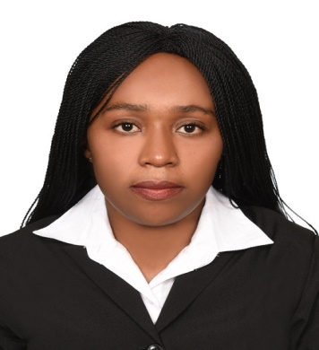**PERSONAL DETAILS:**

Full name : JUDY WANJIKU WAINAINA

Nationality : Kenyan

Date of Birth : 20 th Aug 1994

Marital Status : MARRIGE

Religion : Christian

Languages : English kiswahili

Email Address : jwainaina306@gmail.com

Contact Number : +971563902924

Position applied : WAITRESS CASHIER AND BARISTA

**CAREER OBJECTIVES:**

To secure a suitable position in a company that will offer opportunities for advancement and growth while utilizing my skills and improve my knowledge in an environment that recognizes ones aspiration for career advancement and commitment to succeed.

**SKILLS AND ABILITIES:**

To consistently provide guest the best espresso experience and efficient friendly, high level

Customer service, make the best and tasty coffee

**EXPERINCE : CURRENTLY**

**CRISPY BURGER –AL AIN**

**HIGHLIGHT**

* Maintained high standards of customer service during high-volume, fast-paced operations
* Communicated clearly and positively with coworkers and management
* Mastered point-of-service (POS) computer system for automated order taking
* Handled currency and credit transactions quickly and accurately
* Followed procedures for safe food preparation, assembly, and presentation
* Assisted management with inventory control and stock ordering
* Built loyal client through friendly interactions and consistent appreciation

* Resolved complaints promptly and professionally
* Cross-trained and coordinated scheduling with team members to ensure seamless service
* Took initiative to find extra tasks when scheduled duties were complete.

**COMPANY: BURNSEA HOTEL**

**POSITION:** BARISTA

**DATES:** JANUARY 2018 - DECEMBER 2016

* Prepare or serve hot or cold beverages, such as coffee, espresso drinks, blended coffees, or teas.
* Clean or sanitize work areas, utensils, or equipment.
* Clean service or seating areas.
* Check temperatures of freezers, refrigerators, or heating equipment to ensure proper functioning.
* Describe menu items to customers or suggest products that might appeal to them.
* Order, receive, or stock supplies or retail products.
* Provide customers with product details, such as coffee blend or preparation descriptions.
* Receive and process customer payments.

**COMPANY: CRAY FISH HOTEL KENYA**

**POSITION:** BARISTA WAITRESS

**DATES:** MARCH 2015 - JUNE 2014

* Opens or closes coffee shop
* Maintains time-keeping, temperature logs, inventory and cash handling duty
* Checks quality of coffee stocks
* Checks operating status of all equipment
* Works with Purchasing to ensure punctual delivery of stocks and supplies
* Creates and updates coffee and food preparation guidelines
* Supervises and manages the coffee preparation
* Addresses all issues, concerns, and complaints from customers
* Ensures cleanliness of the coffee shop
* Cautions guests of unsafe and hazardous activities
* Audits and inspects safety, working condition and maintenance of all equipment.

**EDUCATIONAL BACKGROUND**

**THIKA INSTITUTE OF MANAGEMENT**

DIPLOMA IN TOURISM MANAGEMENT AND HOSPITALITY

CERTIFICATE IN TOUR GUIDING

**KENYA INSTITUTE OF MANAGEMENT.**

**CERTIFICATE COMPUTER PACKAGES**

* Microsoft word., Power point, Microsoft outlook and Excel

**INTEREST:** Swimming, Socializing, Travelling and Art.

**Profile**: Friendly, loyal, committed, self motivated, team player, ambitious, enthusiastic and confident.

**Strength:** Detail-orientation and numerical aptitude, excellent interpersonal skills and communication skills, Attention to details, organized.

**References**

**References available on request**