CURRICULUM VITAE
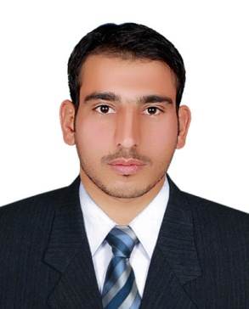  Muhammad Jawad  s/o Sher Zamin  Date of Birth  June, 04 ,1996  NIC No  16102-6048278-7  Nationality  Pakistani  Religion  Islam  Address  Village & Post Office Shergarh  Tekhsil: Takht Bhai  Distt: Mardan  Contact  Cell: 92-311-6690009  Whatsapp: 0308-4909010  Email Address  Jawadssgr@gmail.com  Domicile  District Mardan  Interests & Activities  Reading and playing Cricket  Languages  Pashto, Urdu, English.  Can read, write & speak fluently. | CAREER OBJECTIVE To continue my career with an organization that will utilize my management, supervision and administrative skills to benefit mutual growth and success in the field, I am keen to contribute to an organization’s success through the use of my exceptional managerial and inter personal skills. Demonstrate an organized, focused and resourceful approach to All management endeavors/assignment.  PROFESSIONAL E X P E R I E N C E Worked as an Internee in District Administration Mardan under National Internship Program phase II from 1st July 2017- 30th JUNE 2018 - Assisted in the efficient daily operations of the computer system division. - Planned and carried out daily tasks as directed by management. - Generated day to day reports and repairs as required. - Mastered effective daily use of Microsoft Office Products for record keeping and retention principles. - Also Managing and troubleshooting hardware and software related issues. Work as an Office Assistant in Tehsil Revenue Accounts Assistant Commissioner Office Takht Bhai From 1st July 2018-till date - Dealing all types of Accounts at office. - Data enter into the computer.  PROFESSIONAL E D U C A T I O N PROFESSIONAL S K I LL S REFERENCES - Bsc (Computer Scince) Marks obtain :- 296/550 University of Malakand - BA Marks obtain :- 319/550 Abdul Wali Khan University Mardan - DAE (Computer Hardware) Marks obtain :- 2039/3100 BTE Peshawar - Metric (Sience) Marks obtain :- 638/1050 BISE Mardan - DIT (Ms-Office ,word, Power Point, Excel, In page) From BTE Peshawar with Marks 1118/1400 - Punctual, Responsible and hard working. - Can manage critical situations. - Having good public relation & Interpersonal Skills. - Have good analytical abilities. - Can easily sift essential information from non essentials. - Available on Request

