CURRICULUM VITAE 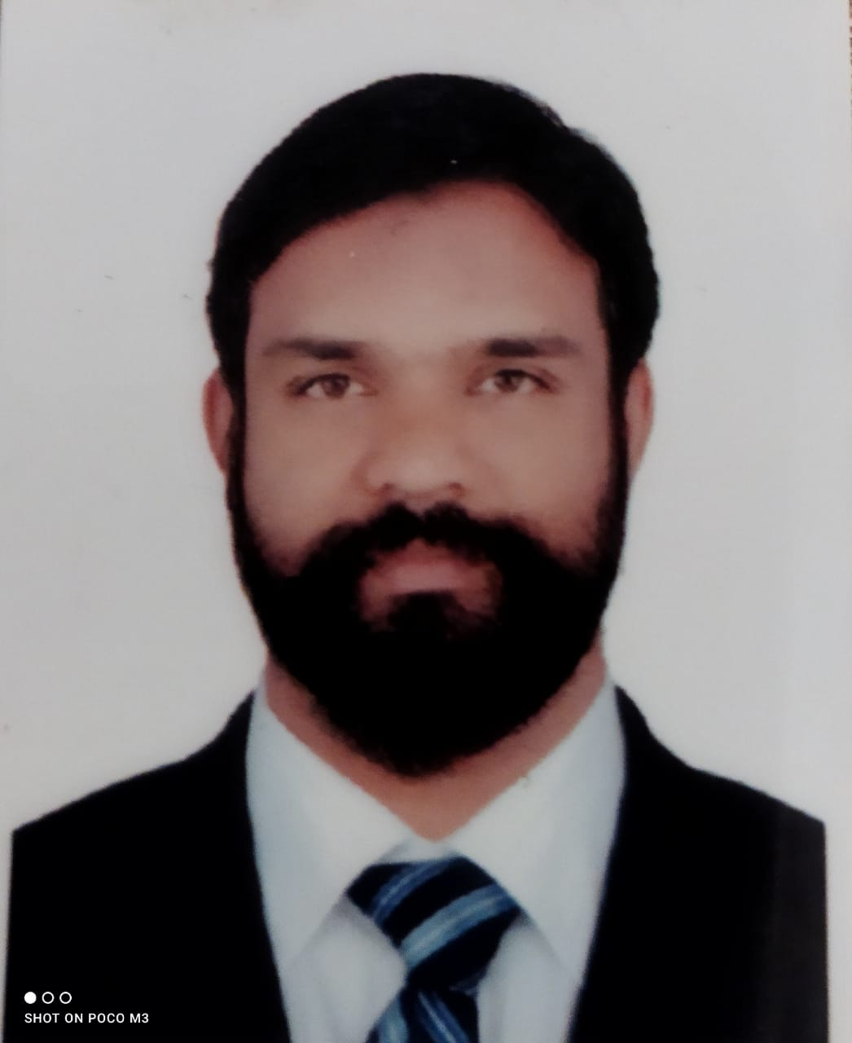

ALI VELUTHARIAL

Mobile: 00 971 052 1482554
aliminamadina@gmail.com
Career objective
Public relations officer, with more than 4 years of experience with leading companies. I am self-motivated and highly resourceful; I enjoy collaborating with others to achieve the department
and company key objectives.

Areas Of Interest
- Public relations officer

Work Experience

Group Of Al Madina UAE

- Processing of all Company Registration Documents (Trade license submission to Economic Department,Tenancy contract submission to Municipality and Chamber of Commerce, MOFA)
- To process, distribute and manage the visa applications, visa renewals, medical reports, passport expiries and transfer processes of all visa and immigration applications
- Process all applications in the system for labour contracts via Ministry of Labour for new and existing Employees ensuring all records for the company on the Labour system are up to date and within the quota
- Distribute daily activities amongst all PRO’s and track daily progress of applications to ensure completion
- Process all applications for various tourist/service visas for guests/clients
- Maintain all labour contracts, Emirates ID, passport with visa copies and photos on the HR network and employee files
- Provide general PRO support to departments for any activity involving the local authorities, including responsibilities for business licenses, permissions etc
- Process police permissions, NOC and other government required documents
- Arrange attestation requisites from Government offices
- Deal with general enquires regarding PRO functions promptly and efficiently enhance the level of department service
- Maintain confidentiality and security of company and employee documents at all times
- UAE Local laws, regulations and procedures
- Experience in using government online application systems

- Labor and Immigration
- All visa activities for the assigned Legal Entities including new visas, renewal of visas, visa transfer and cancellation. All types of visas including employment; visitor; transit; Project visas
- Processing labor/immigration related registrations (new, renewal and transfers)
- Be the point of contact internally for employees for all visa and labour related formalities
- Processing family visas and related documentation for employees on married status
- Point of Contact for all government authorities related to Labor and Immigration
- Dealing with all Government Departments, Ministries, Consulates and Embassies
- Provide guidance and assistance for Business visa submission to foreign Embassy and Consulate for outward travel
- Provide support to Legal department, Retail Back Office and Marketing for all promotions and formalities associated with the business General support to departments for anything involving the local authorities and replacing the Government Relations Specialist during his/her absence
- Collect and provide periodical updates from the government authorities on all Labour and immigration rules to keep the HR department abreast of the changes in the rules and procedures
- Support businesses to deal with Customs, CID, Traffic Department, Police Department, Civil Defense Department, Fire Department as required
- Lead the overall activities performed by PROs and Administrative Assistance related to Labor/Immigration
- Report and escalate any issues to the Regional Immigration Leader
- Provide guidance to the Businesses with regards to applicable/new regulations in place in a timely manner Custodian of HR petty cash for visa processes and labour related expenses – including preparation of petty cash statement and supporting documents for finance
- Four years in Public Relations Officer role within an international company

Contracting company KSA

On business

14year from 2003 to 2017

Academic Qualification
- Diploma – international Academy of Engineering Technology and Management, Aluva - Kerala/India
- Higher Secondary School – GHSS High School Kodungallur - Kerala/India

Computer Knowledge

- Microsoft Excel/Word 2010/Power Point
- Internet, Email & Browsing

Strengths
- Strong Self-Motivation
- Sincere and Committed to Work
- Adaptive by Nature
- Diligent Worker

Personal Details

Date of Birth : 01-06-1979
Gender : Male
Nationality : Indian
Marital Status : Married
Languages Known : Arabic, Hindi, English, Thamizh and Malayalam
License : Valid driving licence issued in UAE, KSA & INDIA
Passport/Visa Details
Passport number : S6917670
Passport Expiry : 29/08/2028
Visa status : Employment
Expiry date : 13/10/2022

Declaration

I hereby declare that information given above is true and correct to the best of my knowledge and belief.ee in U.A.E

Ali Velutharial

