M  Z |  | 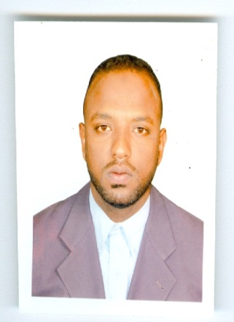  Mohamed Zaroug
 |  | ADMINSTRATIVE OFFICER/ENGINEER
 | +971 50 669 0935 |  |  | ABOUT ME
 | Faoo81@hotmail.com
 | Abu Dhabi, UAE |  |  | An Engineer with more than 10 years of experience in administration and database management. | Able to amalgamate his collaborative and communication skills to deliver projects and tasks at the optimum time frame.
 | DATE OF BIRTH: 11-12-1981
 | NATIONALITY: SUDAN
Skills  Networks Installation  8 / 10  Computer Systems  9 / 10  Communication  9 / 10  Administration  10 / 10  Programming  7 / 10  Education  Bachelor’s degree in electronics engineering  Alneelain University, Khartoum, Sudan  2001-2006  ID: 784-1982-4726353-1  Drive licenses : 713448 |  |  |  | Experience  Administrator Officer  Abu-Dhabi Education Council/ UAE/ 2009-2018 MOE  Worked at multiple schools in the western region, Abu-Dhabi  - Preparation of regular administrative reports.  - Database management and security.  - Maintenance of computer systems.  Administrator  AL MOUSA COMPANY  Worked in construction company as coordinator 2009 -2011  Engineer  Sudanese Islamic Bank/ Sudan/2006-2007  - ATM & troubleshooting.  - PC maintenance and troubleshooting.  - Troubleshooting programming & configuration.  - Implementation Work request.  - Other network function.  Engineer  Petrobash / Sudan / Jan2007-Mar2007  - PC maintenance and troubleshooting.  - Supervision of network.

References Training
- Abdulla Al Hammadi, Alflah School Manager, Madinat Zayed, Abu-Dhabi,UAE, 028882789, abdulla-aa.alhammadi@adec.ac.ae

CCNA
DATANET/ Sudan/ Aug2006-Sept2006

Installation and configuration LAN
Computer center of Alneelain University/ Sudan/ Feb2004-Mar2004

IT Professional Skills

- Able to work independently and efficiently to meet deadlines.
- Able to promptly answer support related email, phone calls and other electronic communications.
- Self motivated, detail-oriented and organized.
- Experience with hardware and software issues.
- Proficient in Internet related applications such as E-Mail clients, FTP clients and Web Browsers.
- Excellent communication (oral and written), interpersonal, organizational, and presentation skills.
- Typing proficiency: 40-60 wpm.
- Perfect command of windows client (XP, 2000, VISTA, 7, 8) server (2000, 2003, 2008)
- Perfect command of all Microsoft office tools
- Web design (HTML, FrontPage)

Attended Workshops

- Avaya IP phone system troubleshooting
- CCTV troubleshooting
- Finger print troubleshooting
- Cisco Network Support
- Konica Minolta photocopier troubleshooting
- Printer’s and scanner’s troubleshooting
- Cisco Wireless Access Point Network Support

