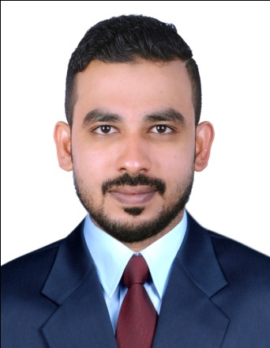**MUHAMMED SAKIR T.A**

**Accountant**

**PERSONAL PROFILE**

**Email ID : shafzi143@gmail.com**

**Contact No : 0553709555**

Nationality : Indian

Sex : Male

Religion : Islam

Date of Birth : 21-June-1989

Passport No : H9686681

Marital Status : Single

Language skills : English, Hindi, Malayalam, Arabic

Experience : 5 years

**OBJECTIVE**

To get enrolled in a challenging and rewarding career in Accounting, industry which utilizes my Accounting and analytical skills, and support growth opportunity in the work place. To induce my patience and potentiality to carry out and record the accountabilities of the company to the full faith and honesty.

**ACADEMIC QUALIFICATION**

* B.com (Bachelor of Commerce) from Kannur University 2011.
* Diploma inpractical Accounting (Manual &Computerized)
* Diploma In Computer Application(DCA)
* Higher Secondary Examination (HSE) from Board of Higher Secondary Education, Kerala.

**COMPUTER SKILLS**

* Tally
* Peach tree
* Quick book
* MS office (word, Excel, PowerPoint, Access)

**WORK EXPERIENCE**

**High Gifts Collection Abudhabi (April 2015 to June 2019)**

**United Arab Emirates**

**Accountant**

* Supervise all regular accounting processes such as Accounting Payable, journal entries and monthly closure accounts.
* Analyse and forcast financial requirements for organisation.
* Monitor authourised account reconciliation process.
* Administer all bank transations and oversee data recording procedures monthly.
* Analyse different general ledger accounts regulerly.
* Develop budgetory plans for processes as per requirment.
* Provide support to safe keeping of internal expenses in company.
* Manage and maintain finance related programs and documents inclusive of future plan and programes.
* Analyze monthly report of the companies and report to the management
* Manage account assistances for preparing and maintaining Budgets, Forecasting, and Payroll.
* Prepare Payables, Receivables and Invoices
* Ensure follow up of international standard accounts principle
* Comparison with past ,present and budgetary performance of the companies
* Find the Liquidity, Safety, Profitability and Efficiency of the companies with the help of Ratios
* Report comment and suggest to the management of the firms
* Discuss with the firm’s management of different firms for evaluating Co performance
* Maintain cash and bank Account OD
* Maintain purchase register and sales register.
* Credit outstanding statement reports and over dues payable with ledger and bill wise.
* Co ordination with Auditors
* Data entry
* Cash managing
* System operating

**Accounts Practical Training Ambadi lane, Kochi-35. (May 2011 to June 2013)**

**Kerala, India**

* Two year had been worked in the M/S Accounts (Accounts Contractor) in India
* Analyse finalizing and Auditing multinational companies

**Accounting Clerk**

* Maintain cash and bank Account OD
* Maintain purchase register and sales register.
* Credit outstanding statement reports and over dues payable with ledger and bill wise.
* Co ordination with Auditors

**Other Key Responsibilities**

* Maintaining Cash Book & Day Book
* Petty Cash & General Banking Works
* Assisting for auditing works
* Preparing Salaries & Wages
* Secretarial works
* Follow up for receivable amount
* General Office administration

**ADDRESS, INDIA**

* Faisal Manzil, Pallathimar, (po) Kodiyamma (Via) kumbala, kasaragod (DT),

kerala, India pin 671321

Tel: 00919995711432

* Happy CafteriaBuilding, Room no 302, Near kish travels

Madinath Zayed, abudhabi, , UAE.

I do hereby certify that the above particulars furnished by me are true and correct according to best of my knowledge.

**Muhammed sakir T.A**