**ESTHER EVANGELIN S**.

# CONTACT

India-+971-7868834326

**U.A.E**- +971-543452436

**Mail**:estherselvan95@gmail.com

# LOCATION

# India Address

West sivanthipuram,

Ambai TK -627425

# Tirunelveli.Tamil nadu,India

# U.A.E Address

# Humadiya,Al surf,7 star building

# 7 star super market,ajman

# United Arab Emirtes

# CARRIER OBJECTIVE

Looking for a challenging and responsible position to work in an organization in which I can exhibit my technical skills in achieving the desired objectives of the organization and willingness to learn and grow with the organization.

**CO-CURRICULAR ACTIVITIES**

Attended the DST sponsored “**A THREE DAY ENTREPRENERSHIP AWARENESS CAMP**”

Attended the state level seminar on “**DIGITAL MARKETING AND SAFETY IN SOCIAL MEDIA”** in Einstein college of engineering.

Attended the one day training program on professional development conducted by “**BOTHI TREE SKILLS”** in CSI Jayaraj Annapackiam college.

Attended the green batch sponsored “**NSS CAMP**” IN CSI Jayaraj Annapakiam college.

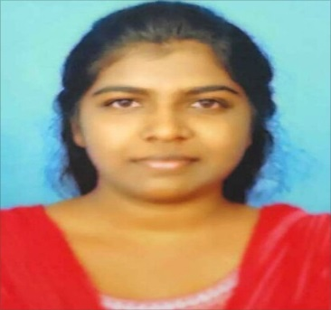

**EDUCATION**

MBA Einstein college of engineering, Tirunelveli

2015-2017*(pursuing) 6.2(cgpa) (upto 2nd sem)

BBA CSI Jayaraj, Annapackiam College, Nallur

2013-2015 (60%)

HSC P.L.W.A.HR.Sec.school, vickiramasingapuram

2011-2012 (75%)

SSLC P.L.W.A.Hr.Sec.School, vickiramasingapuram

* 1. (55)

**AREA OF INTEREST:**

* HRM, Marketing

**TECHNICAL SKILLS:**

* Type writing in English: LOWER- I st class
* HIGHER- II nd class

**TRAINING PROJECT DETAILS:**

**Degree**: MBA Summer Training

**Project title**:n organizational study on SRI Gomathy mills

(P)Ltd,Veeravanallur

**Objective:** To know all the functional departments and its

Working conditions of an organization

# 

**PERSONALPROFILE:**

Name : S.ESTHER EVANGELIN

Date of Birth : 24.06.1995

Father’s name : J.SELVAN

Nationality : Indian

Gender : Female

Marital status : Married

Language known : Tamil, English

# 

# WORK EXPERIENCE:

1 Year experience in **”**The hope Matriculation school”

As a teacher (2017 to 2018).

**DECLARATION**

I hereby declare that the information furnished above is true to the best of my knowledge.

**Place**: Tirunelveli Signature

**Date**: (S. ESTHER EVANGELIN)