**RESUME**

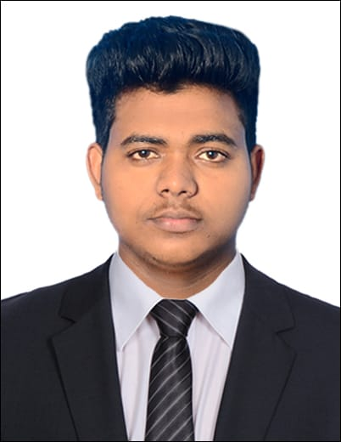**VIGNESH R**

2/1223,sreelakshmi,karakkad,

Kodumb,palakkad

Kerala-678551

Mail: **vigneshvicky8953@gmail.com**

Ph: 9074734412

**CAREER OBJECTIVE**

To succeed in an environment of growth and excellence and earn a job which provides me job satisfaction, self-confidence and help me to achieve organizational as well as personal goals.

**EDUCATION QUALIFICATION**

|  |  |  |  |  |
| --- | --- | --- | --- | --- |
| **DEGREE** | **INSTITUTION** | **UNIVERSITY/BOARD** | **YEAR OF PASS** | **Percentage****%** |
| DIPLOMA  (MECH) | JCT Polytechnic College, Madukkarai, Coimbatore, Tamilnadu | DOTE | 2019 | 62% |
| 10th | Rosi modern english medium school, palakkad,kerala | CBSC | 2013 | 60% |

**PROJECT**

**Main project :** fabrication of automatic hammer forging machine

**AREA OF INTREST**

|  |  |
| --- | --- |
| * Sales & marketing | * Manufaturing |
| * Maintenance | * Material science |
| * Quality control |  |

**TECHNICAL CONCEPT**

|  |  |
| --- | --- |
| * Meticulous and quick learner | * Mechanical diploma concept |
| * Decision making and problem solving | * Leadership quality |

**EXPERIENCE**

|  |  |  |
| --- | --- | --- |
| **Company name** | Kalari express | Gilbarco veeder root |
| **Position** | Field executive | Machine operator |
| **Experiance** | 1 year | 1 year |

**PERSONAL STRENGTH**

* Positive Attitude
* Effective communication skills
* Hard working
* Self confidence

**PERSONAL INFORMATION**

|  |  |  |
| --- | --- | --- |
| Dob | : | 24 - 09 -1997 |
| Father name | : | Ravi s |
| Mother name | : | Lakshmi r |
| Gender | : | Male |
| Language known | : |  |
|  |  | Read - English, Malayalam |
|  |  | Write - English, Malayalam |
|  |  | Speak - English, Tamil, Malayalam |

**DECLARATION**

I, hereby declare that the information provided above are true to the best of my knowledge.

**DATE :**

**PLACE : (**Vignesh r**)**