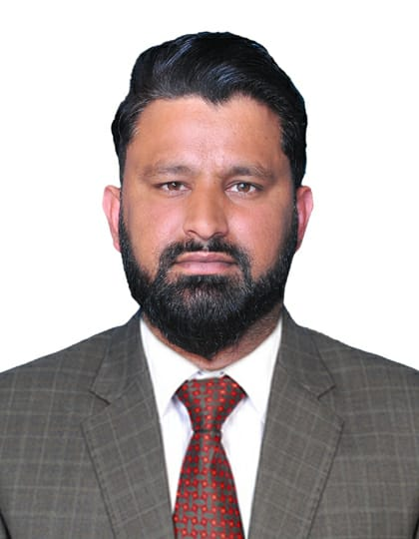

Muhammad Abdullah
E-mail Address: abdullahriaz133@gmail.com
Mobile #: 0553201003
Present Address: Musaffah,Abu Dhabi

CAREER OBJECTIVE

A detailed-oriented human resource with proven strong ability to establish and maintain an effective filing and archiving system for both hard and electronic documents in accordance to company and project procedure.

PROFESSIONAL QUALIFICATION & SKILLS

- Knowledgeable in P.L.O.C. techniques (planning, leading, organizing and controlling) in situations that need proper decision making
- Familiar with (EDMS & ERP) Electronic Data Management Systems / Enterprise Resource Planning (ACONEX, CMS, JPLUS, SAP)
- Proficient in Microsoft Office tools (MS Word, Excel, Power Point and Outlook)
- Excellent in administrative, organizational and management skills
- Demonstrable ability to work on smaller multiple projects and complete high-quality work against strict and conflicting deadlines
- Good working knowledge of Office software (Word, Excel, PowerPoint,etc.)
- Highly organized, able to plan and manage conflicting priorities
- Computer literate (basic knowledge of MS Windows Excel, Word and internetsystems)
- Good working knowledge ofShare Point of view
- Ability to work well under pressure and deliver quality results ontime
- Good interpersonal skills and ability to communicate effectively with various management levels
- Strong organizational skills, including an ability to prioritize activities and work with limited supervision
- Excellent organizational skills, accuracy and attention to detail

EMPLOYMENT HISTORY

Al Asab General Transport & Construction Est.

ADNOC onshore South East Tie-In Project, Asab, Western Region of Abu Dhabi, UAE From November 2016 ‘to Oct 2020

Position: Human Resource officer.

Key Duties and Responsibilities:

As HR Officer; (Nov 2016 to Oct 2020)

- Document Control & Filing (copying, scanning/printing - renaming, converting, binding, recording all incoming hard or electronic copies of documents related to HR (Internal and External).
- Develop and maintain document control processes for the efficient management and recording all documentations
- Maintaining the logs of under process Candidate’s required documents such as CV, certificates, Job experience letters, employment / agency contracts, filled up forms and keeps these important documents confidential and well managed.
- Ensure that all the relevant HR documentation are registered / maintained in the electronic Document Management System( EDMS)
- Create and manage document hierarchy and process systems.
- Check and edit incoming documents and prepare for distribution (submittal &transmittal)
- Maintain a safe and secured working environment within Document Control

- Distributes communication letters/Internal Office Memorandum (IOM), maintaining scanned copies of incoming and outgoing documents with log records for easy tracing threads of Transmittals and Over all Communications.

Payroll administrator Skill

- Excellent verbal and written communication skills
- In-depth understanding of human resources and labour rules and regulations
- Attention to detail and strong numeracy skills
- Working knowledge of payroll software
- Strong organisational and time management skills
- Ability to prioritise tasks effectively

Timekeeper; (Nov 2015 to Oct 2016)

- Receive, Review and Log all essential documents such as time cards, time sheets and work charts for all Site working employees including sub-contractors supplied manpower.
- Compute and post details of production and hours worked to the payroll department
- Calculate wage deductions by reviewing leave, vocation and sick records
- Verify employees’ attendance manually and electronically
- Justify any deductions in the salary by providing on paper proof to employees
- Coordinate with account and departmental heads for payroll process
- Calculate incentive and commission for employees
- Evaluated timecards for accuracy on the regular and overtime hours.


Kamal Group of Industries:
Pakistan,
Position: HR Assistant

Key Duties and Responsibilities:

- Coordinate with all of site timekeepers
- Monitoring labor hours through system as well as manual timekeeping
- Allocates the work force to various site/location/supervisor as required
- Collects allocation sheets form site in charge
- Approves the OT as per the overtime sheet signed & approved by project manger
- Prepare the hired tradesmen monthly time sheets and get approval to pay from project manager
- Random site checks to make 100% output from the workforce by not allowing workers to take extra rest/break hours and late reporting early leaving etc.
- Maintained proper records of employees proceeding on leave returning form leave absconded resigned and terminated
- Manpower manning sheet, leave, absconded & termination list maintaining

Toyota Sargodha Motors:
Pakistan
Position: Sales Executive


Key Duties and Responsibilities:

- Customer follow up
- Maintain the Banks Document
- Customer dealing
- Reporting assistant in TWSM (Toyota ways sales and Marketing)
- Make the nenkey for the year

ON-THE-JOB TRAINING
Habib Bank Ltd.


Six-month experience in HBL in car finance department Pakistan,

- File processing
- Document processing & filling
- Reporting
- Finance Recovery

TRAININGS & SEMINARS

  - Introduction to Safety First
  - H2S Level 1 [ H2S and Breathing Apparatus]
  - H2S Level 2 [H2S Awareness
  - Basic First Aid and CPR
  - Basic Fire Fighting
  - Safe Rigging and Slinging
  - Tactical Response Training

EDUCATION
BACHELOR OF SCIENCE IN ECONOMICS - Year; 2010-2014
University of Sargodha, Pakistan

PERSONAL INFO

Nationality: Pakistan
Date of Birth: 25th of March, 1990 Religion: Islam
UAE Driving License No : 2457109

