

About me

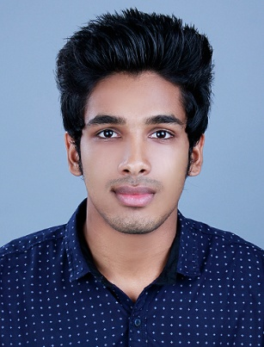

Mr. Hashil Abbas KK

hashilabbaskk@gmail.com

Image result for phone icon+917025202155

**Image result for LOCATION iconKerala, India**

**B Com from Calicut University**



CAREER OBJECTIVE

To utilize my professional skills, Experience and knowledge acquired in reaching my potential and achieving the goals of a respective organization hence build a stronger career.



PROFILE

* A dedicated individual who possesses excellent problem solving, sourcing, decision making, team building, coordination, organizational and supervision skills.
* Strong customer service skills, with the ability to diffuse difficult situations.
* Can handle multiple tasks effectively and very much flexible with time.
* Expert in handling people of diverse nationalities..
* Proficient in general office duties, including accounting and customer service.
* Excellent communication skills, work very well with diverse nationalities.
* Possesses excellent organizational skills and can work well independently.

**Academic Qualification:**

**B.COM** - [2016-2019, CALICUT UNIVERSITY, Kerala India]

**HSC** – Commerce [2014-2016, The ST Josephs Higher Secondary School, Wayanad, Kerala, India]

 **Technical Skills: [Proficient in the use of:]**

Knowledge in MS Office tools Word, Excel, Power point, etc.

Internet and Email Applications, Outlook etc.

* **Personal Details:**

|  |  |
| --- | --- |
| Name | Hashil Abbas K K |
| Father | Abbas K K |
| Date of Birth | 20-03-1997 |
| Age | 22 |
| Marital Status | Single |
| Nationality | Indian |



* **Languages Known:**

|  |  |
| --- | --- |
| **To Speak** | English |
| Malayalam |
| Tamil |
| **To Write & Read** | English |
| Hindi |
| Malayalam |





* **Interests:**

o Observing leading business leader’s achievement of success in business life.

o Driving and meeting with different nationality peoples and study culture.

** References:**

Will be available upon request,