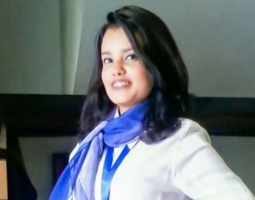AL barsha 1, Dubai, UAE

Cell: +971527294515

manar.ata.mohamed@gmail .com

<https://www.linkedin.com/in/manar-hosney-4306671a5/>

manar hosney

|  |  |  |  |  |  |
| --- | --- | --- | --- | --- | --- |
| Objective | |  | | Recently graduated from mass communication department, faculty of arts with long experience in organizing major events during my college time. After graduation I shift my career to sales where I found my way to achieve one of my goals to get experience in customer service and business awareness.  I am looking for new challenge in a respectable origination where I can be an added value by implementing what I learn previously to achieve company goals and enhance my experience in new fields. | |
| Work History | |  | | **Sales Stylist JEN 2020 UP TO DATE**  **LEVI’S ADM , UAE**   * Helping our customer by showing all our products and which more suitable for him or her * Daily and weekly financial reports * Receiving the products from warehouse and putting the correct   **Customer service for online games store " the puzzle city” 2019.**   * Post information about our products, responding all customer inquiries.     **Call center agent –NEW HORIZON educational center 2016-2018**   * Redirect calls, mails to the concern department. * Register complains on the system to get the concern department to contact the customer. * Explain to existing visitors or prospect clients center courses offers.   **Call center agent at HARVEST – Educational center 2015- 2016**   * Redirect calls, mails to the concern department. * Register complains on the system to get the concern department to contact the customer. * Explain to existing visitors or prospect clients center courses offers.   **Receptionist at KMG- fitness center**   * Answer telephone calls and take a messages. * Schedule and confirm appointments. * Handle incoming and out coming mails. * Providing support to existing customers.   **Receptionist at AL-RYADA HOSPITAL**   * Answer telephone calls and take a messages. * Schedule and confirm appointments.   **Telesales and Receptionist at EGYPTION COMPANY FOR ELECTERICAL DEVICES.**   * Schedule and confirm appointments. * Providing support to existing customers. * Handle incoming and out coming mails. | |
| Trianing | |  | | AMI,” mark media project “Feb –may 2016.  CDCE, leadership camp, July – sep 2018.  FOS, ICDL course (word – PowerPoint- oracle-x-store). | |
| Education | |  | | **Bachelor of** Mass communication department, faculty of arts, pr and advertising sector.  CGPA : 2.9 | |
| Certificates | |  | | UNHCR certificate in recognition for contribution as member of media & marketing committee.  BIBLIOTHECA ALEXANDRINA in recognition for contribution as pr member during the cultural program of the Alexandria international book fair. | |
|  |  | |  | |
| Personal INFORMATION |  | | Marital Status: SINGLE  Date of birth: 8 JUNE 1997  Nationality: Egyptian | |