**CURRICULUM VITAE**

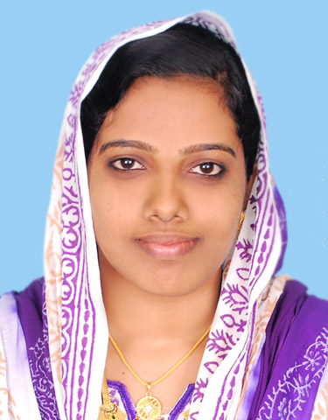

**UMMUL FAIZA. K**

**Address : Jannath(H),Palazhi,Calicut-14**

**Contact No : +918136909311**

**Email Id** : [**faizajannath2@gmail.com**](mailto:faizajannath2@gmail.com)

**CAREER OBJECTIVES:-**

*More than 2 years of working experience as a Receptionist &* *Guest Relation Executive, looking forward for a challenging position in the firm to provide me a platform where I can show my talent and responsibility towards increasing company’s day to day activities and performance.*

**ACADEMIC CREDENTIALS:-**

* **BACHELOR OF ARTS (Functional English)***,* JDT Islam College, Calicut *(University of Calicut-****2011)***
* **Diploma in Professional Accounting** (Both Indian and Foreign Accounting).

**PERSONAL SKILLS:-**

* A quick learner with ‘**Can do**’ attitude.
* Leadership skill
* Good computer knowledge and documentation skills
* Knowledge in Accounting works
* Customer service
* Effective communication skills.
* Teaching skill
* Thrive in deadline-driven Environments.
* Optimistic in nature.
* Quality-oriented and creative
* Ability to work under pressure.

#### TECHNICAL SKILLS:-

* Advanced MS Office Excel, Word and Power Point
* Tally ERP, Peachtree

**ACHIEVEMENTS:-**

* Achieved a certificate from Institute of Palliative Medicine, as a trained community volunteer.
* Achieved an appreciation certificate, for the warmest “Smile” in Matria.

**WORK EXPERIENCE:-**

**1) Organization : MATRIA Exclusive Women & Child Hospital, Calicut, Kerala**

**Designation : Guest Relation Executive**

**Duration : 18th October 2017 to till the date**

**Job Role & Responsibilities:-**

* Customer service,welcoming clients and answering their queries.
* Receiving of payments by cash and cheques.
* Appointment generation.
* Issuing receipts to clients.
* Submission of daily collections to the Accounts Department.
* Time management.
* Billing (Both Op & IP).
* Encoding of Daily and Weekly reports.
* Insurance cordinations.

**2. Organization : Baby Memorial Hospital, Calicut, Kerala**

**Designation : Receptionist (Customer Relations)**

**Duration : 13th June 2011 to 12th June 2012**

**JobRole& Responsibilities:-**

* Front office Management.
* Referring enquiries.
* Time management.
* Handling room reservation.
* Cash Handling (Both petty and other)
* Billing (Both OP & IP)
* Appointment Generation
* Customer’s Handling

**PERSONAL PROFILE:-**

Father’s Name : Koyamon. K

Age & Date of Birth : 29, 02/04/1990

Marital status : Married

Nationality : Indian

Languages Known : English,Hindi, Malayalam andTamil

Permanent Address : Jannath (H), Po. GA College, Palazhi,Kozhikode – 673014

Mobile : 8136909311,9633205153

Email : [faizajannath2@gmail.com](mailto:faizajannath2@gmail.com)

Reference : Will be provided on request

**DECLARATION:-**

I hereby declare that the above mentioned details about me are true and correct to the best of my knowledge and belief.

UMMUL FAIZA. K