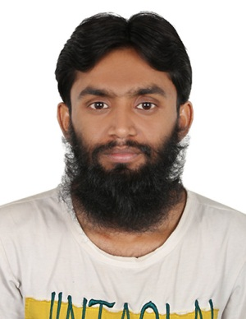

**Mutahir Saleem**

**Daira DUBAI**

**Cell# 0097-1563-3380-16**

**E-Mail: asadaligg84@gmail.com**

**___________________________________________________________________**

**OBJECTIVE:**

* **Be a part of growing organization with bright chances of growth and opportunity of enhancing learning skills. Work for competitive environment, which enable creativity**

**and innovation in my day to day life.**

**PERSONAL BIO-DATA:**

**Father’s Name :   Muhammad Saleem**

**Date of Birth :** 24-04-1992

**CNIC : 784-1992-1910257-3**

**Religion :   Islam**

**Nationality :   Pakistani**

**Marital Status : Single**

**ACADEMIC QUALIFICATION:**

**Matriculation**

**PROFESSIONAL SKILLS:**

* **Basics of Word**

**EXPERIENCE:**

* **4 years experience as a Sales man in DUBAI.**

**LANGUAGES:**

* **English &Urdu**