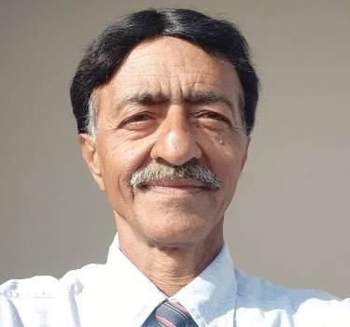Anil Kumar Sachdev,

BOO6-1658/2, G.T.B. NAGAR,

NEAR LITTLE ANGEL SCHOOL,

O/S SHIVJOT MINI MARKET, KHARAR 140301,

MOHALI, PUNJAB.

[Astrologer.india@yahoo.com](mailto:Astrologer.india@yahoo.com)

Date of Birth : 28 Feb 1957

Mobile : 9104952254

WhatsApp : 9427522544

To,

Dear Sirs,

Sub: Post applied for: Astrologer/Principal/G.M.

Qualification : “Jyotish Ratnam” from “Brahad Gujarat Astrology Society Ahmedabad’ in 2001-02.

“Crash Course in Astrology” from “Academy of Vedic Astrology” Ahmedabad in 2010.

I have and studied hundreds of Astrology books.

Experience : I am a vedic Astrologer since 25 years.

I have made, studied and predicted thousands of Horoscopes correctly, also given right remedies.

Since a year, full day I am working as an online Astrologer, having WIFI.

I also received Sanman Patra as a “ Jyotish Tilak from Brahad Gujarat Astrology Society Ahmedabad in 2001.

Languages known : Hindi, English, Gujarati, Punjabi, Sindhi.

I am a matured, healthy, hard working and result oriented person.

Thanking you and awaiting your favorable reply, assuring my best services always.

Yours Sincerely,

Anil Sachdev, Astrologer