**MARIA GORETTI KASEKYA**

Sex: Female 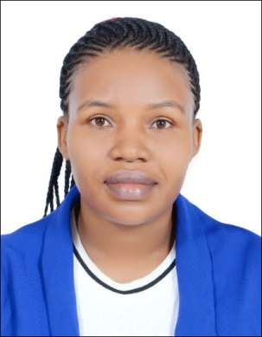

Passport number: B1073078

Date of birth: 3 October 1984

Nationality: Ugandan

Mobile number: +971547855623

E- mail: kasegore@gmail.com

Languages: English and Arabic

With UAE driving license

Position desired: **Receptionist/ Administrative Assistant.**

**PERSONAL SUMMARY:**

A highly efficient and competent Administrative Assistant with an ability to ensure that a company complies and operates in accordance with statutory and legal provisions. This offers opportunities for career development and advancement.

I have experience of attending meetings with company shareholders and the board of directors and acting as a point of communication between them. I have excellent organizational skills, highly efficient and hard working.

**WORK EXPERIENCE:**

**Administrative Assistant SWT 2014 Augast-Dec2020**

Responsible for ensuring that the highest standards of administrative processes &

Corporate governance are both promoted and maintained, so that the business operates efficiently and in accordance with all statutory and legal provisions.

**Duties:**

• Responsible for all company secretarial functions, duties and responsibilities.

• Organizing, preparing agendas for, and taking minutes of board meetings.

• Monitoring changes in the business legislative and regulatory environment.

• Providing advice to colleagues and senior managers on administrative matters.

• Maintaining statutory books i.e. registers of members, directors and secretaries.

• Developing & implementing admin policies & procedures to improve efficiency.

• Preparing and filing dormant accounts.

• Maintaining all statutory registers.

• Drafting minutes within set timeframes.

• Reporting in a timely & accurate manner on company procedures & developments.

**Receptionist SWT April 2011- March2014**

**Duties:**

* Serves visitors by greeting, welcoming, and directing them appropriately.
* Notifies company personnel of visitor arrival.
* Maintains security and telecommunications system.
* Informs visitors by answering or referring inquiries.
* Directs visitors by maintaining employee and department directories.
* Maintains security by following procedures, monitoring logbook, and issuing visitor badges.
* Operates telecommunication system by following manufacturer’s instructions for house phone and console operation.
* Keeps a safe and clean reception area by complying with procedures, rules, and regulations.
* Supports continuity among work teams by documenting and communicating actions, irregularities, and continuing needs.
* Contributes to team effort by accomplishing related results as needed

**KEY SKILLS AND COMPETENCIES**

* Strong organizational and time management skills.
* In depth knowledge of secretarial software, Outlook, Microsoft excel and Word.
* Excellent presentation, interpersonal & communications skills - both written & oral.
* Active team member with self-drive and motivation.
* Acting with the highest ethical standards and always treating others fairly and with respect.
* Creative & innovative thinker.
* Telephone Skills
* Listening
* Professionalism
* Customer Focus
* Handles Pressure

**ACADEMIC QUALIFICATIONS**

• Bachelor of Information Technology MakerereUniversity (2006-2011)

• Uganda Certificate of Education Mary hill High school (2004-2005)

• Certificate of Ordinary Level St. Maria Goretti Secondary school (2000-2003)

**REFERENCES** – Available on request.