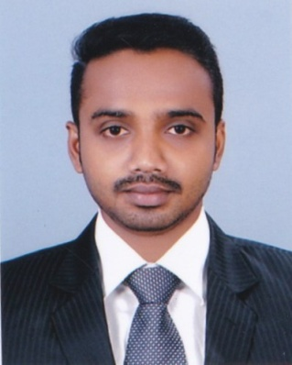 **CURRICULUM VITAE**

**PRINCE PL**

B.Com ( accounting & co-operation)

Email : [princepl0786@gmail.com](mailto:princepl0786@gmail.com) MOB: 91 9544138129

**Career Objective**

To work in an environment which offer a good opportunity to share my knowledge and skills with other and participate myself and work towards for a complete satisfaction of the company.

**Educational Qualification**

|  |  |  |
| --- | --- | --- |
| **Qualification** | **Year of passing** | **Name of Board / University** |
| **SSLC** | **2010** | **KERALA BOARD OF EDUCATION** |
| **PLUS TWO (COMMERCE)** | **2012** | **KERALA HIGHER SECONDARY BAORD** |
| **B.COM** | **2015** | **KERALA UNIVERSITY** |

**Computer Proficiency**

* **Accounting package, Tally**
* **Ms office ( window all version )**
* **Ms excel**

**Work experience**

* **One year experience as an accountant assistant in sreekumar associate and tax consultant attingal, trivandrum kerala India**
* **Two year experience as an accountant in milco dairy attingal, trivandrum kerala, India ( Ksheera Vyavasaya Sahahakarana Sangam Ltd, (Milco) )**

**Work Description**

* Up to finalization of Accounts
* Day today accounting work
* Maintaining petty cash
* Preparation of payroll
* Preparation of trail balance and profit and loss accounts
* Monthly closing reporting to management
* Preparation of bank reconciliation statement
* Handle of all account payable and receivable
* Ensuring all the dues to and from the companies have monitored and reconciled periodically
* E- filing
* Co ordination annual audit of the company

**Languages Known**

* ENGLISH
* MALAYALAM
* HINDI

**Personal Skills**

* Positive Attitude
* Hardworking
* Self-confident

**Passport Details**

* Passport No. - M9240801
* Date of Issue - 25/05/2015
* Date of Expiry - 24/05/2025
* Place of Issue - Trivandrum
* Visa status - Visting

**Personal Details**

* Father’s Name : Pushkarashan
* Date of Birth : 14/05/1994
* Religion : Hindu
* Gender : Male
* Marital Status : Single
* Nationality : Indian
* Residence Address : Indraprestham

Anachal Kalamacha PO

Vamanapuram

Thiruvanathapuram

Kerala India PIN 695 606

**Declaration**

I here by declare that the above furnished statements are true and correct to the best of my knowledge and belief.

**PRINCE.P.L**