***Ghada Ajamieh***

***Certified Speech-Language Pathologist.M.A.***

***Auditory Verbal Therapy (AVT)***

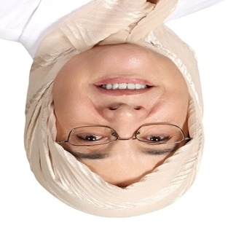

Dubai, UAE

Mobile:+971-50-4505085

E-mail: [ghahaj@yahoo.com](mailto:ghahaj@yahoo.com)

***NATIONALITY:***

Jordanian.

**EDUCATIONAL *BACKGROUND***

* IOWA / IOPI Device
* Talk tool course
* Stuttering course
* Lidcombe program
* Auditory Verbal Therapy**-** (AVT course- certificate- Awarded in 2012).
* WE Listen International Inc.:

Principles of AVT, and how to practice techniques, strategies and procedures for helping parents to help their children who are deaf or hard of hearing to achieve maximum use of their auditory potential for developing the spoken conversation.

* **University of Jordan**, Department of Phonetics and Linguistics, Master of Arts Degree (**M.A.**) in Communication Disorders and Speech Pathology (Awarded in 1999).

**Experiences**

* American hospital Dubai since 2007 up to date: at ENT Clinic- Specialty Centre for Cochlear Implant and other speech and language disorders.
* Rashid Paediatric Therapy Centre Dubai 2004 -2006
* The University of Jordan */* Linguistics and Phonetics 1999 - 2003.

**Speech and language pathology professional practice and services**

* **advocacy**
* **supervision**
* **administration/leadership**
* **Collaboration**
* **Assessment:** differential diagnosis of disorders of communication, speech, and language disorders can occur developmentally or acquired.
* **Treatment:** develop and implement treatment to address the presenting symptoms or concerns of a communication or related functional issue.
* **Counseling:** Parent counseling

**Speech-Language Pathology****Service Delivery Areas**

1. **Auditory Habilitation/Rehabilitation**

* Speech, language, communication, and listening skills impacted by hearing loss, deafness
* Auditory processing
* developmental disabilities (e.g., specific language impairment, autism spectrum disorder, dyslexia, learning disabilities, attention-deficit disorder, intellectual disabilities, unspecified neuro- developmental disorders).
* **Pre-Feeding skills**

1. **Fluency**
2. **Speech and Language disorders :** 
   1. Post cochlear implant and hearing Aids users
   2. Language disorders related to: Aphasia, Apraxia, Dysarthria, cerebral palsy, down syndrome, autism spectrum disorder, functional language disorder.
   3. Articulation
3. **Voice:** functional voice disorder

**Resonance:** Hyper-nasality- Hypo-nasality

1. **Cognition**

**Languages: - Arabic as a native speaker.**

* **English**

**Conference Presentations.**

**Public interviews.**