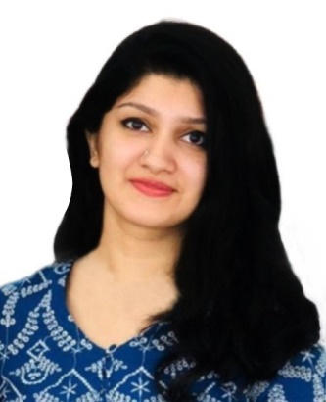 |  | SAMYUKTHA SUNILKUMAR NAMBIAR
Profile  Being a committed individual, want to be part of a renowned organization, to contribute towards the growth of the organization, based on my expertise and to further my personal capabilities by learning from the new exposure within the structured framework of the organization. To work on a challenging job profile which provides an opportunity to enhance my technical skills and knowledge, this could provide me an insight into new aspects so that it would be helpful for my career.  PERSONAL DETAILS  Nationality: Indian  Date of Birth: 18-11-1998  Gender: Female  Marital Status: Single  Contact  +971522708299  samyukthanambiar@gmail.com  Hobbies  Dance  Endurance Sports  Community Involvement  Travel  Sudoku  Cooking |  | EDUCATION  Gulf Indian High School, Dubai, U.A.E  2008-15  Chinmaya Vidyalaya, Kerala, India  2015-17  Amity University, Dubai, UAE  2017-2020  Course: B.com Honours  Volunteer Experience or Leadership  Dubai Club for People of Determination (Volunteer)  December 2017  (Guiding athletes on information, helping the special needy etc.)  Professional Worldwide Controls (Doping Control Officer)  2018- Present  (Sample collection personnel of Doping)  Biju’s Learning App (Promoter)  2018  (Guiding about application’s yearly packages and other facilities)  Space Pattern Interior Decoration LLC. (Assistant Accountant)  2019  (Worked as a part of the Internship Programme)  SKILLS  - Ms Office (Advanced Excel , Word, Powerpoint)  - Accounting Softwares (Tally ERP, Peachtree, Quickbooks)  - Java Net beans IDE & My SQL  - Verbal and Written Communication  - Patience  - Determined and Result Oriented  Linguistic abilities  - English: Full Professional Proficiency  - Malayalam: Full Professional Proficiency  - Tamil: Full Professional Proficiency  - Hindi: Limited Working Proficiency  - Arabic: Limited Working Proficiency

