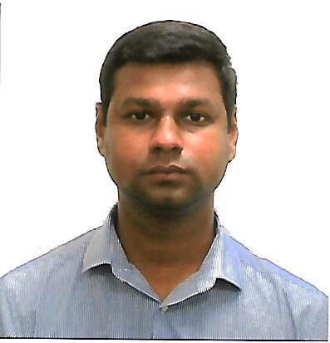**SAMEER AHMED**

Al Muraqqabat Rd, Deira - Dubai.

Email : [a.sameerahmed@gmail.com](mailto:a.sameerahmed@gmail.com)

Contact : +971 52 744 0651

**OBJECTIVE**

To obtain a long-term career with an organization which has a strong background that provides good opportunity for enhancement of professional and personal status.

**WORK EXPERIENCE**

**UNITED ARAB EMIRATES**

**Admin Cum Account Assistant**

ABDA Cargo Services DMCC, Dubai, UAE (April 2014 - Present)

* Work Experience as an Accounting Assistant or Accounting Clerk.
* Knowledge of Basic Bookkeeping Procedure.
* Hands-On Experience with MS Excel and Accounting Software (Tally ERP & Zoho Book).
* Organization Skills Ability to Handle Sensitive.
* Online Bank Transactions.
* Immigration Related Work.
* Other Office Related Work.
* Registration of Vehicle.
* Sound Knowledge of Labor Law.
* Collections.

**Assistant to Public Relations Officer (PRO)**

Al Liali Jewellery LLC, Dubai, UAE (January 2014 – April 2014)

* Bank Transactions.
* Immigration Related Work.
* Registration of Vehicles.
* Sound Knowledge of Labor Law.
* Collections.

**INDIA**

**Air Ticketing and Reservation Clerk**

Akbar Travels, Pondicherry, Tamilnadu, India (2012 – 2013)

* Booking Air Tickets and Advise Customers.
* Manage Contact Lists and Customer Spreadsheet.
* Make Travel Arrangements to the Staffs for Office Trip.
* Prepare and Sent Out the E-mail Newsletter.
* Prepare Meeting Materials.
* Handle Client Inquiries by Phone or E-mail.
* Other Office Related Works.

**EDUCATION**

**Bachelor of Business Administration (2010 – 2012)**

Tamil Nadu Open University, Thanjavur, Tamil Nadu, India

**Diploma in Advanced Airlines and Travel Management Programme (2010)**

Institute of Airlines and Travel Agencies, Tiruchirappalli, Tamil Nadu, India

**Higher Secondary School (2008 – 2009)**

Fatima Mariam Higher Secondary School, Madukkur, Tamilnadu, India

**SYSTEM EXPOSURE**

* Tally ERP.
* Zoho Book.
* MS Office.

**PERSONAL STRENGTH**

* Highly motivated and eager to learn new things.
* Effective time management.
* Strong motivational and leadership skills.
* Ability to work as individual as well as in group.

**PERSONAL DETAILS**

Date of Birth : 10TH December 1988

Gender : Male

Nationality : Indian

Languages Known : English, Tamil, Hindi, Malayalam

Passport No : U2972768

Driving License : Light Motor Vehicle (Manual)

**DECLERATION**

I hereby declare that all the information and particulars mentioned above are true to the best of my knowledge and belief.