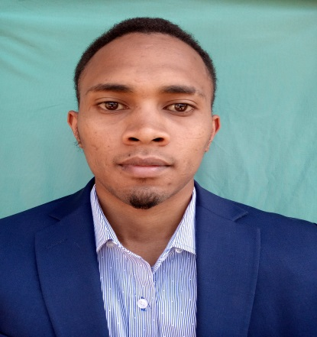  PERSONAL DETAILS  Nationality: Kenyan  Race: Mixed race  National ID no: 33989073  Religion: Christian  Gender: Male  Date of birth: Oct 4th 1995  Marital Status: Single  CONTACT  Address  P.o Box 7429  Nakuru, Kenya  Phone  +254738889018/  +254718259060  Email  Elkington.armstrong@gmail.com  Linkedin  Linkedin.com/Howard  PROFFESIONAL  Ability to work on own initiative and as a team.  Good communication skills.  Physically fit and able to handle crisis in emergency situation.  Willing to work scheduled overtime.  REFERENCES  ANN MARANGA  HEAD OF DEPARTMENT  HOSPITALITYAND TOURISM  MACHAKOS UNIVERSITY  PO BOX 136-90100  MACHAKOS  Cell phone: +254720733571  MIDLANDS HOTEL  ADDRESS: Reservations@midlandhotel.com  Cell phone: 0706600000  WATERBUCK HOTEL  ADDRESS: Reservations@waterbuckhotel.co.ke  PO BOX 203-120010  PETER K. MUNGAI  CALDERA SUITS  PO BOX 6847-00200  CELL PHONE: 0721270567 | ELKINGTON HOWARD ARMSTRONG  Hospitality and tourism professional  PROFILE  A passionate, service-focused individual who likes meeting challenges head on and seeing them through in a professional manner. I am a confident team player and adapt to a variety of work situation with ease while maintaining character and professional standards. I am a strong willed person focused in achieving set goal and objectives of organization as well as my own. I am true and loyal to values and standards set by establishment. In addition, I am result-oriented, keen and fast to learn new skills and apply them in my area of expertise.  CAREER  2019-2020 Accountant Caldera Suits  Responsible for taking stock counts from both  bar and store, compiling the daily sales made  from the bar and kitchen, confirming stock  received and issued, making payments to  suppliers, banking daily sales made, compiling  staff debts and advances for monthly payment  and balancing bar and kitchen sales in case of  any less or excess, confirming  captain orders for food and beverage served  From the kitchen.  2018 Tour operator Africa FlashMc Tours & Travel  3 months attachment, from June to August.  duties include booking tours for guests,  organizing and filing documents, escorting  Tourists to game drives and help in keeping  The guests informed. Help in coming up with  Attractive tour packages.  2017 Trainee Midlands Hotel  3 months attachment from April to June. Skills  In respective laundry, kitchen, service, store,  Bar and front office duties.  2016 Food and beverage service practical for 3  Months at Machakos University.  2015 Trainee Waterbuck Hotel  3 months attachment from January to march.  Skills in respective laundry, kitchen, service,  Store and bar duties.  SKILLS  Knowledge of computer applications such as  excel, word, adobe illustrator, POS software  etc.  Team player.  ACADEMIC QUALIFICATIONS  2015-2019 BA of Science in Hospitality and Tourism  Management at Machakos University. Grade  (2nd Class Honors)  2011-2014 Kenya Certificate of Secondary Education at  Bahati Day High School. Mean grade  B(Plain)  2000-2010 Kenya Certificate of Primary Education at  Kawa Academy. Mean grade B(Plain)  OTHER AFFILIATIONS  2020 Pursued driving at Budget driving School for  1 month.  2015 Pursued computer packages at Nairobi Baptist  Centre (NBC) for 3 months  LANGUAGES SPOKEN  ORAL WRITTEN  English Advanced(fluent) Advanced(fluent)  Kiswahili Advanced(fluent) Advanced(fluent)  French Fair Fair  PERSONAL ATTRIBUTES AND LIFE SKILLS ACQUIRED  - Strong team spirit, problem solving ability.  - Honesty and Integrity.  - Team work.  - Adaptability.  - Self-motivated and discipline.  - Interpersonal skills.  INTEREST AND HOBBIES  - Hiking and travelling.  - Playing keyboard and making musical beats.  - Exploring.  - Swimming.  - Playing basketball.  - Socializing and meeting new souls.

