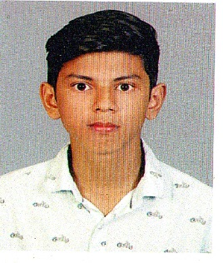
MAZIN BAKOR D B

Darul Baramy

Areekkad

Nallalam P O

Calicut- 673027

Mobile: +91 9567871109
Email Id: mazinbaramy151198@gmail.com

CAREER OBJECTIVE

To pursue a rewarding career, seeking for a job in challenging and healthy work environment where I can utilize my skills and knowledge efficiently for organizational growth.

ACADEMIC QUALIFICATION
- SSLC
- Plus Two
- BBA

COMPUTER SKILL
- Tally 9 ERP
ACADAMIC SKILLS
- Conducted a study on the topic “Attitude of people towards Insurance policies” – done it as a part of my sixth semester project
LANGUAGES KNOWN

- Malayalam
- English
- Tamil

PERSONAL PROFILE

Date of Birth : 15/11/1998

Father’s Name : Aboobacker Koya P P

Gender : Male

Nationality : Indian

Marital Status : Single

REFERENCE

B M ATHEM MALIK , ACMA
ATHEM MALIK B M & ASSOCIATES

DECLARATION

I hereby declare that the information furnished above is true to the best of my knowledge.

MAZIN BAKOR D B

