RESUME
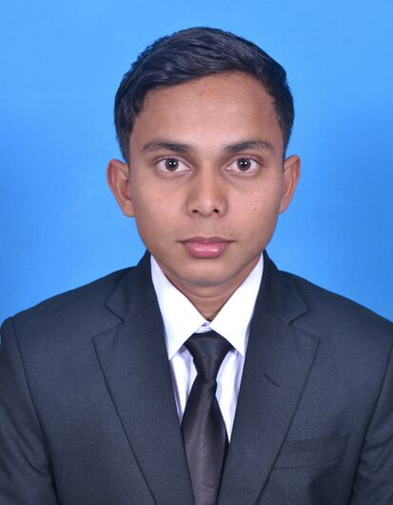
JINARUL SEIKH
Vill- Kashimnagar
P.O-Natunpara Raipur
Dist: - Murshidabad,
West Bengal.
Pin: - 742165
MOBILE NO: +7074326800,8391856252
Email id:-jinarulsk333@gmail.com
CAREER OBJECTIVE:-
- Wishing to gather practical knowledge. Now looking for a prosperous future in Hotel Industry to be a good Hotelier.
CORE COMPETENCE:-
- Determined for success.
- Flexible and can easily get adapted to any corporate culture.
FUNCTIONAL SKILLS & STRENGHT:-
- Maintain the cleaniness, quality and standard of the property.
- Hard working ,honesty.
- Self confidence.
- Time management.
- Straight forward.
COMPUTER KNOWLEDGE
- DIPLOMA.
ACADEMIC QUALIFICATION:-
Examination passed | Board | Year of Passing
HIGHER SECONDRY | W.B.C.H.S.E | 2016
Madhadayamik | W.B.B.S.E | 2014

WORKING EXPERIENCE:-
- 22 week's experience on industrial training from courtyard Marriott Bhopal. I got a star intern Card during the intership.
- 11 month's work experience in HOUSEKEEPING department From courtyard Marriott Bhupal.
QUALIFICATION:-
- I have completed my 3YEARS DIPLOMA IN HOTEL MANAGEMENT & CATERING TECHNOLOGY FROM SCHOOL OF INDIAN HOTEL MANAGEMENT.
- From Kalyani,Nadia, West Bengal.

LANGUAGE PROFICIENCY:- | Language | Read | Writer | Speak
LANGUAGE PROFICIENCY:- | English | Yes | Yes | Yes
LANGUAGE PROFICIENCY:- | Hindi | No | No | Yes
LANGUAGE PROFICIENCY:- | Bengali | Yes | Yes | Yes
PERSONAL DETAILS:-

Fathers name : - Mr. FAJLUL SEIKH
Date of Birth : - 02-07-1998
Nationality : - Indian.
Sex : - Male.
Marital status : - Single.
Computer Knowledge : - Basic Knowledge.
Hobby : - Playing Football
DECLARATION:-
I hereby declare that all information mentioned above is true to the best of my knowledge & any conflict regarding the information will be solely my responsibility.

Date:
Place: Signature

