***CURRICULUM VITAE***

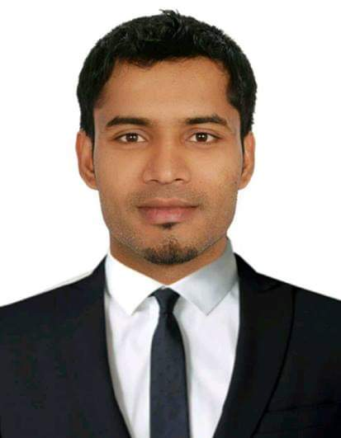

**Mujaheed Alam**

Flat # 412 Al Jabbri Tower

Al Quasis, Dubai, UAE   
Contact: **+97155 3261501**

Email: [**alam.dxb@yahoo.com**](mailto:alam.dxb@yahoo.com)

**CAREER OBJECTIVE**

To be able to accomplish a responsible position where my skills, capabilities, experience and accomplishment will allow me for the opportunity related with career expertise. Also, to be able to exceed the high standard of professionalism & quality service, for the organization I may be associated with in future.

**PROFESSIONAL EXPERIENCE**

**Company M and M Marketing (Direct Sales Agency for Emirates NBD)**

**Designation: Credit Officer, Since Feb 2019 till date**

**Location: Dubai, UAE**

**ROLES & RESPONSIBILITIES**

* Steering various activities and reporting to the Relationship Manager
* Keep on learning and being updated with the new policies of the bank.
* Being creative and pro active.
* Conveying your ideas and give solutions to the customer’s need and their requirement.
* Achieving over and above of my assigned targets.
* Conduct market research to identify selling possibilities and evaluate customer needs
* Set up meetings with potential clients and listen to their wants.

**PREVIOUS EXPERIENCE**

**Company : First Gulf Bank**

**Designation : Sales Executive since Nov 2014 to Sept 2015**

**Location : Dubai, UAE**

**ROLES & RESPONSIBILITIES**

* Sales of credit cards, Personal loans, Company Visiting and listing and cross sales of other banking products.
* Business Development through cold calling, networking.
* Gather data to understand the trends.
* Increase sales by creating strategies to meet goals.
* Achived sales target of the month with in the acceptable risk standard.
* Preparing a daily call and sales register and maintained a good DSR for making marketing strategies.
* Answered inbound calls in support of customer’s needs, conveyed in a reassuring manner step by step instructions to resolve application issues.
* Effective meeting clients expectations and handling and reduction of clients complaints

**Company : Gulf News LLC, Dubai, UAE.**

**Designation : Sales Executive from March 2009 to Oct 2014**

**Location : Dubai, UAE**

**ROLES & RESPONSIBILITIES**

Directly report to the Team Leader &Area Managerwork as a team and discuss various strategies and planning to achieve the set target, attending weekly basis meeting to discuss and make a strategic plan related to the major queries and requirements of the customers.

**Sales & Marketing**:-Responsible for achieving the monthly sales target & marketing operations with focus on achieving sales growth, focus on maintaining the market value of existing products and services.

* Sales and marketing of Gulf News products.
* Getting new clients to the company through Cold calling, networking.
* Convincing the customers for purchase
* Gather data to understand the trends.
* Preparing weekly reports containing meeting status.
* Maintain records of existing clients and future prospective clients.
* Maintain confidential information of the customers and maintaining good Customers loyalty.

**PREVIOUS EXPIRIENCE**

**Company : Raymond**

**Designation : Sales Executive from Feb 2005 to Nov 2008**

**Location : Forum Mall, Bangalore, India**

**ROLES & RESPONSIBILITIES**

* Responsible for handling walk-in customers, explaining about the products to the customer.
* Convincing the customer for purchase.
* Preparing Invoicing and handling other administrative work.
* Preparing daily reports containing meeting status.
* Maintain records of existing clients and future prospective clients.
* Maintain good Customer loyalty.
* Places orders to restock goods and handled receiving products.
* Reporting to the Manager of the Store.

**PERSONAL ATTRIBUTES & SKILLS**

* Comprehensive knowledge of the methods and techniques of sales and marketing.
* Strong analytical and problem solving capability.
* Well Development communication, Negotiation skills, personal and Administrative abilities.
* Highly motivated, energetic and positive team player.
* Computer proficiency, Windows, Ms Word, Ms Excel, Power point and Internet.

**ACADEMIC QUALIFICATION**

* Commerce Graduation from Mysore University College, Hassan 2004
* High School Graduation from Hoysalla Pre University College, Hassan in 2001

**OTHER QUALIFICATION**

* Microsoft office From (NIIT) Bangalore India
* Talley 7.2

**PERSONAL DETAILS**

Date of Birth : 07 April 1983  
Nationality : Indian  
Languages known : English, Urdu, Hindi,Kannada, Tamil &Telugu.   
Passport No : P9034473   
Visa Status : Employment Visa

**DECLARATION**

I hereby declare that the information furnished above is true to the best of my knowledge, willing to personally explain any further details required

**(Mujaheed Alam)**