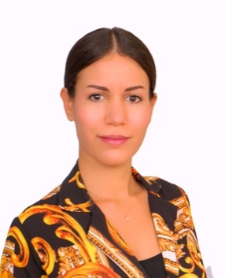

**First name :** LALLA TOURIA

**Family name :** Cheikh

**Nationality :** Moroccan

**Phone number:** 00971565593998

**Email address :** [lallatouriacheikh@gmail.com](mailto:lallatouriacheikh@gmail.com)

**Driving license :** UAE 2016

***LANGUAGES***

**ARABIC :** Mother tongue

**ENGLISH :** Fluent

**FRENCH :** Fluent

***OBJECTIVE***

Grow professionally through continuous education in working and promote company's excellence through highly competitive services.

***CERTIFICATS AND DIPLOMATS***

**2008:** Computer certificate

**2007:** University degree private law in at faculty of judicial sciences, economics and socials

**2002:** Bachelor mathematical science

***WORK HISTORY***

**Sales manager July 2020 to present**

**AYS DEVELOPERS**

**.** Implementing new strategic and long-term relationships to develop the business and build company’s reputation

**.** Contact potential clients through calls, emails…to offer them property consultancy services

. Carry out the marketing of property availability to attract prospective clients

**.** Evaluate investors’ budget and objective to identify their needs and requirements

**.** Build and establish good working relationship with different developers and agencies

**REAL ESTATE PROPERTY CONSULTANT April 2018 to October 2019;**

**PANTHEON DEVELOPMENT**

**.** Generate leads by active networking, making outbound calls and relationship building

**.** Ensure all leads and enquiries are attended to as per best customer service practices; follow

up with clients on a regular basis

**.** Determine clients ‘need and financials abilities to propose solutions that suit them

Provide guidance and assisting buyers in purchasing properties under the best terms through

Company’s` policy (SPA; Snagging; handover; collections…)

**REAL ESTATE PROPERTY CONSULTANT June 2017 to April 2018;**

**AZIZI DEVELOPMENT**

**.** Advertising properties through a variety of marketing techniques

**.** Evaluating the clients desires and economic capabilities to appropriate suggestions

**.** Provide information regarding legal guidelines, rates, specifications and property availability

**SENIOR SALES EXECUTIVE AND MAKE UP ARTIST December 2014-June 2017;**

**CHALHOUB group Dolce & Gabbana, Gucci**

**.**Assist the customers in meeting their needs in providing a professional services andproduct knowledge

**.**Achieve personal sales target by using advanced sales techniques and focusing on selling and up selling

**.**Maintain high standards of visual merchandising in term of cleanness, display and stock rotation prepare production and status reports on a weekly basis to the manage

**.**Build strong relationships with customers and deal with diverse customer basis

**SALES EXECUTIVE October2009- October 2014;**

**DUTY FREE shop Morocco Airport and U.A.E. Airport**

**Beauty, watches jewelries and bags**

**.**Assist the costumerin meeting their needs and presenting the most suitable products according to customer requirements

**.**Guaranty cross selling of products and achievement of the sales goals.

**.**Responsible for through checking of deliveries, inventories, receiving invoices, quality and quantity of items

**.**Cashiering payments through credit cards and cash in all internationals currencies

***SKILLS:***

**.**Proficient in using Microsoft Word, Excel and power point

**.**Hardworking, quick learner and capable of performing under pressure.

**.**Good communicator skills, flexible,organized,disciplined,motivated and energetic.