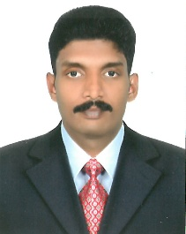

**UMESH V.K  
Mob: +971569716575   
Email:umeshvk152@gmail.com**

**OBJECTIVE**

To grow with a dynamic and progressive organization which offer sample career growth and diversified exposure, to excel in my career by achieving the company’s objective

**EDUCATIONAL QUALIFICATION / LICENCE**

* BCA (Bachelor of Computer Application – 2010)
* Plus Two (March 2007)
* S.S.L.S (March 2005)

Driving License - Light Motor Vehicle (DUBAI)

**WORK EXPERIENCE**

* 2 Years Worked as a **Marketing Executive** in **INDIA**.
* 5 Years Worked as a **Security Supervisor** in **DUBAI UAE.**
* 1 Year Worked as a **Store Keeper** at **HPL** in **INDIA.**

**PERSONAL INFORMATION**

* Father Name Balakrishnan
* Date of Birth 10-11-1989
* Gender Male
* Marital Status Married.
* Nationality India
* Religion views Hindu

**PASSPORT INFORMATION**

* Passport No L2821235
* Date of Issue 13-Agu-2013
* Date of Expiry 12-Agu-2023
* Place of Issue Calicut
* Visa Status Visit Visa.

**LANGUAGE KNOWN**

* English, Hindi, Malayalam, Tamil

**SKILLS**

* MS OFFICE ( Word & Excel )
* Operating System ( Windows XP, 7 & 10 )

**DECLERATION**

I hereby declare that the information furnished above is true to the best of my knowledge and belief.

**UMESH V.K**