**RESUME**

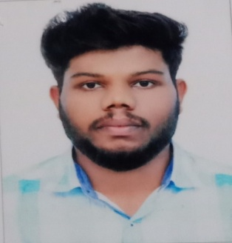

**SUDHEESH .M**

**OTTAKALLUTHODI HOUSE**

**MANNARMALA POST**

**MALAPPURAM DT**

**KERALA**

**INDIA, PIN: 679325**

**MOB: +91 9747843518 , 6238569701**

**EMAIL: sudheeshsudhi072@gmail.com**

**CAREER OBJECTIVES**

My career objective is to achieve a good position which would continuously challenge my skills and abilities and knowledge there by to work and ensure and dedication and sincerity in an esteemed organization.

**PERSONAL DETAILS**

Date of Birth : 24/08/1999

Gender : Male

Marital Status : Single

Father’s Name : Haridas .M

Nationality : Indian

Religion : Hindu

**PASSPORT DETAILS**

Passport Number :XXXXXX12

Date of Issue :XXXXX13

Date of Expiry :XXXX2020

Place of Issue :KOZHIKKODE

**EDUCATIONAL QUALIFICATION**

* SSLC
* Plus Two
* Diploma in Computer hardware & Networking

**LANGUAGES KNOWN**

* Speak: English, Malayalam
* Write: English, Malayalam, Hindi
* Read: English, Malayalam, Hindi

**COMPUTER KNOWLEDEGE**

* MCPA – Master of Computerized Professional Accounting

Knowledge in GST, GCC Tax, ESI and PF, IFRS

Specialized in Tally ERP 9.0 Acro-bis ,Peachtree & Quick Books Accounting software

MS OFFICE

**STRENGTH**

* Good communication skill
* Self confident
* Positive attitude
* Can adapt to any kind of situation
* Ability to deal people diplomatically

**HOBBIES**

* Playing football, cricket
* Travelling to new places

**WORK EXPERIENCE**

* 2 Year working experience as Office Assistant & Cashier at Professional Courier Perinthalmanna

**DECLARATION**

I hereby declare that the information furnished above is true to the best of my knowledge information and belief.

Place: PERINTHALMANNA

03/11/2020 SUDHEESH .M