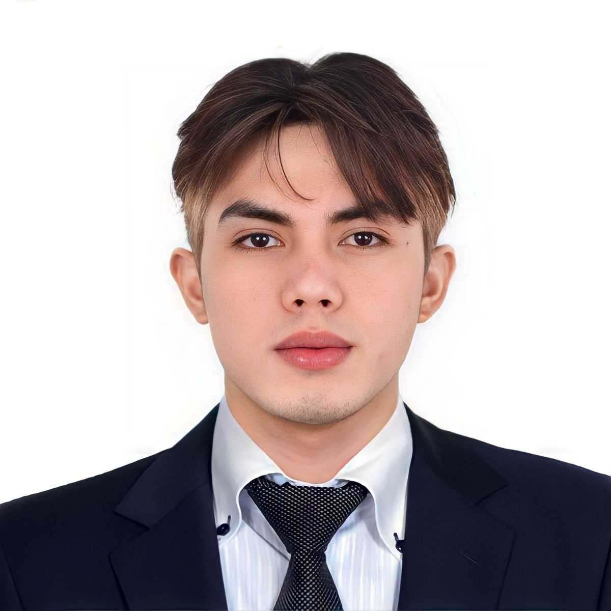**ABDULHAKIM N. ALIH**

**RADIOGRAPHER/CARDIOVASCULAR TECHNOLOGIST-DOH**

Quality Care Medical Center Bldg, Flat 503, Al Lulu Street Abu Dhabi UAE

+971 55 784 9985 | +63 905 257 4676 Whatsapp | [edwardalih@gmail.com](mailto:edwardalih@gmail.com)

**OBJECTIVES**

Seeking a position as a Radiographer in any Hospitals and Medical Center. Offering expertise in interacting with patients, administering radiation treatments, and performing specialized radiography. Exceptional ability to maintain radiography equipment in order to ensure that it remains in good working order.

**Highlights and Qualifications:**

* Proficiency in conducting X-Ray, CT scan,Ultrasound and Flouroscopy procedures.
* Strong knowledge of radiological equipment and technology.
* Excellent interpersonal and communication skills.
* Attention to detail and a commitment to patient care and safety.
* Valid DOH License to practice Radiology Technology in Abu dhabi.
* Valid years of experience in the field.
* Can Join Immediately and willing to work in UAE.
* Wide knowledge Both diagnostic and therapeutic procedures.

**PROFESSIONAL EXPERICENCE**

**MACHINE SPECIALTY**

* XRAY BOTH DIGITAL & MANUAL
* ULTRASOUND
* C-ARM FLUOROSCOPY
* CT-SCAN

**AREA OF SPECIALIZATION**

* Radiologic Department
* Catheterization Laboratory

**CARDIOVASCULAR TECHNOLOGIST/ RADIOLOGIC TECHNOLOGIST**

November, 2017 - March, 2020

Metro north medical center and Hospital (Philippines)

* ﻿﻿Arrange the Cath lab with all the necessary equipment's and consumables for all types of procedures.
* ﻿﻿Performed the technical responsibilities to ensure the usage of all the machines in the Cath lab including the angiographic machine, hemodynamic system, intra-aortic balloon pump, CD work station, thermal printer, high pressure injector etc. according to manufactures instructions.
* ﻿﻿Check for the para meters of all the machines at the start of the day.
* ﻿﻿Connect the ECG electrodes and cable to the patient for continuous monitoring and interpretation for abnormal waveforms.
* ﻿﻿Maintain sterile environment and aids to perform aseptic procedures in the lab
* ﻿﻿Applies radiation protection principles to ensure the safety of the patient and staff
* Maintain the patient logoook with the procedures dala, tindings, materlals used etc.
* ﻿﻿Processing and transferring the acquired images to the workstation.
* ﻿﻿Ensure the hemodynamic monitoring and recording for all patients
* ﻿﻿Observe all health and safety policy and procedures.
* Perform diagnostic imaging procedures ( X-Ray, Ultrasound and CT-scan) with precision and accuracy.

**RADIOLOGIC TECHNOLOGY/ RADIOGRAPHER**

April, 2021 - March, 2023

Health alert Diagnostic Center (Philippines)

* ﻿﻿Ensure the safety and comfort of patients during examinations.
* ﻿﻿Collaborate with radiologists and other healthcare professionals to obtain accurate diagnostic images.
* ﻿﻿Under the supervision of a radiologist, performs diagnostic medical radiographic procedures limited to x-ray examinations of the skull, chest, hip/pelvis, spine/sacrum, upper extremities, and lower extremities
* ﻿﻿Perform diagnostic imaging procedures ( X-Ray, Ultrasound and CT-scan) with precision and accuracy.
* ﻿﻿Verifies the patient's details entered in Radiologic Information system (RIS) / Picture Archiving & Communication system (PACS)
* ﻿﻿Overall responsibilities to provide a good standard and high quality of diagnostic image.

**RADIOLOGIC TECHNOLOGY/ RADIOGRAPHER**

April, 2023 - October, 2023

The Medical City (Philippines)

* Primarily responsible for operating Radiographic equipment to produce high-quality diagnostic images that aid in the diagnosis of various patient conditions. They can specialize in certain areas of imaging, including X-Ray, CT, and Ultrasound..
* Prepare the patient for Radiological procedure by positioning the patient, adjusting immobilization devices & equipment controls to get the perfect exposure.
* ﻿﻿Under the supervision of a radiologist, performs diagnostic medical radiographic procedures limited to x-ray examinations of the skull, chest, hip/pelvis, spine/sacrum, upper extremities, and lower extremities
* ﻿﻿Overall responsibilities to provide a good standard and high quality of diagnostic image.

EDUCATION BACKGROUND

**BACHELORS OF SCIENCE IN RADIOLOGIC TECHNOLOGY**

Brent Hospital and Colleges Incorporated.

2013-2017

R.T Lim Boulevard, Zamboanga City Philippines

PERSONAL INFORMATION

Date of birth: October 30, 1996

Place Of birth: Saudi Arabia K.S.A.

Status: Single

Language proficiency in English and Tagalog and basic Arabic

LICENSE

* Certificate of Passing Philippine Radiologic Technology Licensure Examination in August 2018
* Department of health-Abu Dhabi (DOH) HAAD-MI Licensure Examination for Medical Imaging August 2023

**TRAINING AND SEMINARS ATTENDED**

* 4th annual convention of the Cath lab associates of the Philippines (CLAP)

“Quality and innovations: breakthrough to excellence”

August 25th, 2019

* Philippine Society of Cardiovascular Catheterization and intervention, Inc. (PSCCI) held its 26th Annual Scientific Convention

“PSCCI 2019: Exploring state of the art solution to conventional problems.”

New world Makati hotel, Makati city, Philippines

April 12-14, 2019

* Singapore Live 2020 “29th annual Live interventions in vascular endotheraphy “

Raffles City Convention Centre Singapore

January 16-17, 2020

**CHARACTER REFERENCES**

**MARK LESTER B. TATADEL**

Position: Clinic Coordinator (Health alert Diagnostic Clinic, Philippines)

Contact number:

**RONALDO MANUEL, MD, CARDIOLOGIST**

Position: CHAIRMAN (Metro heart specialists Group Inc., Philippines)

Contact number: +(63) 977-804-2282

*I hereby certify that the above information is true and correct to the best of my knowledge.*