**CURRICULAM VITAE**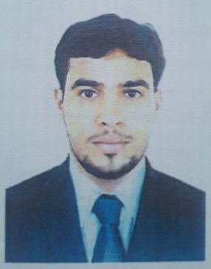

**SAFEEQ P**

Mobile: **0562261525**

Email: [safeeqsuttu@gmail.com](mailto:safeeqsuttu@gmail.com)

**CAREER OBJECTIVE**

I constantly enhance my skills and ensure a position of responsibility at an appropriate level in the organization which will utilize my background abilities and interest while providing opportunity for growth and advancement of myself and organization.

**PROFESSIONAL EXPERIENCE**

Company Name: **PCP Technology FZ co., Jebel Ali, Dubai, UAE**

Position: **Concrete Lab Technician (Heat Operator)**

Period: **3 years**

**Duties and Responsibilities**:

* Schedules and monitors daily testing schedule. Reviews break results and distribute results.
* Communicate with management, field staff and client regarding laboratory testing services.
* Prepares laboratory testing reports and report test results to QC Engineer via appropriate test reports and maintaining test result charts.
* Maintain laboratory in organized manner.
* Manage day to day operations of concrete batch plant and materials testing laboratory.
* Maintain a positive work atmosphere by acting and communicating in a professional manner with customers, co-workers, and supervisors.
* Other duties as assigned by Engineer.

Company Name: **Kenz Hypermarket, Ajman, UAE**

Position: **Merchandiser, Sales Supervisor**

Period: **1 year**

Company Name: **Talal Supermarket Department Store, Dubai, UAE**

Position: **Merchandiser, Salesman and Section In charge**

Period: **4 years**

**Duties and Responsibilities**:

* Welcoming and Greeting Customers
* Responsible for service presentations to clients
* Responsible for follow up and controlling issues at retail level
* Identify and resolve clients problems
* Maintaining eye-catching effectives displays within the office
* Planning product ranges and preparing sales and stock plan in conjunction with buyers
* Liaising with buyers, analysts, storekeeper, suppliers and distributors
* Maintaining stock details
* Forecasting profit and sales and optimizing the sales volume and profitability of designated product areas
* Working closely with virtual-display staff and department head to decide how goods should be displayed to maximize sales

**SKILLS**

* Good communication skills
* Able to perform in pressure and multitasking
* Hardworking
* Adaptable to different situation and people

**EDUCATIONAL QUALIFICATION**

* Secondary school Leaving Certificate
* Plus Two
* Tally

**PERSONAL DETAILS**

Date of birth & Age : 25-03-1990, 29 years

Gender : Male

Nationality : Indian

Religion : Muslim

Marital Status : Married

Languages Known : English, Hindi, Arabic, Malayalam, Tamil.

**PASSPORT DETAILS**

Passport No. : S 8782259

Issue date : 15-10-2020

Expiry Date : 14-10-2025

Visa Status : Employment Visa (Free zone)

**DECLERATION**

I do hereby declare that the above mentioned information is true to the best of my knowledge and belief.

SAFEEQ P