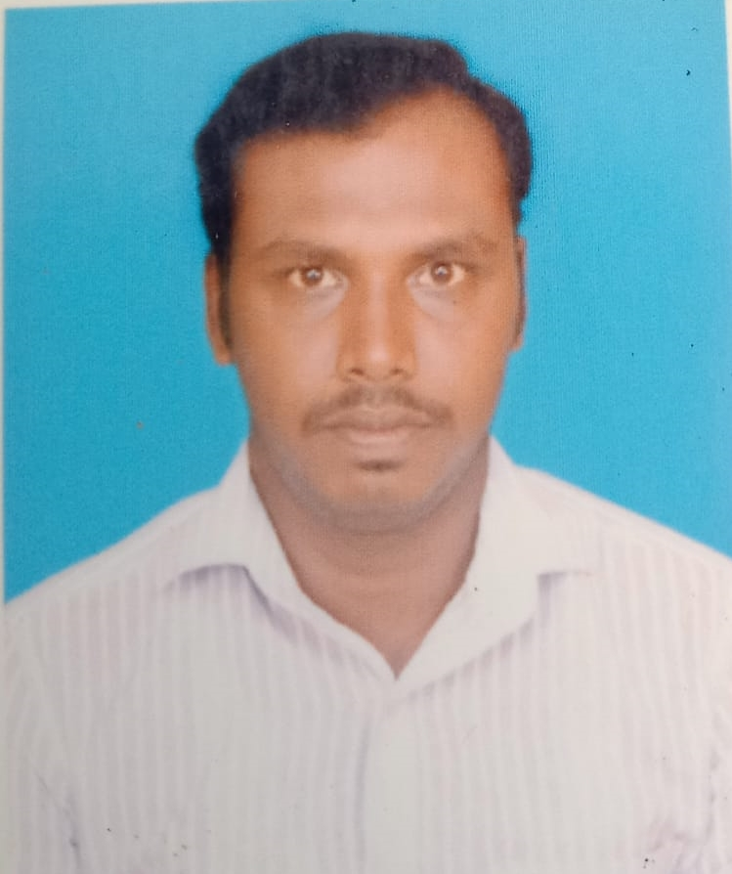

MURUGAN PERIYASAMY

Samymurugan23@gmail.com

+971 582984814

Dubai, UAE

**Career Objective**

Professional individual with experience and knowledge to provide customers with customer service and technical assistance and/or advice. Very willing to learn new areas and I have experience in these areas that can benefit a company and their customers.

**Professional Summary**

* Maintaining receipts, issuing invoices, replenishing stocks, doing basic accounting tasks, reimbursing customers, and removing defective or expired items from shelves.
* Knowledge of goods or materials in assigned storeroom.
* Knowledge of inventory principles and practices.
* Knowledge of supervisory principles and practices.
* Scanning, Printing, Binding, Filing, Typing & Photocopying.
* Excellent knowledge in MS Word, MS Excel, MS Power Point, Adobe Acrobat.

**Professional Experience**

* Worked as a Storekeeper in Crown General Store, Muscat
* Worked as a Data Entry Operator, Al Naba Services, Muscat

**Education**

* D.T. ED DIPLOMA IN TEACHER TRAINING, THANTHAI HANS ROVER, PERAMBALUR
* H.SC, GOVT.HR SECONDARY SCHOOL, SENDURAI
* S.S.L.C, GOVT.HR SECONDARY SCHOOL, SENDURAI

**Work Experience**

**Crown General Store, MUSCAT, 2018-2020**

**Role: STOREKEEPER**

**Responsibilities:**

* Counted and sorted all incoming goods.
* Performed general office and administrative responsibilities.
* Maintain an effective working relationship with all staff.
* Performed interoffice mail activity and special courier requests.
* Contact vendors and responsible for returning damaged goods to vendors
* Track inventory of products on shelves and storage unit
* Create Purchase Orders as needed
* Review invoices, maintains records and performs periodic inventories

**Al Naba Services, MUSCAT, 2010-2015**

**Role: Data Entry Operator**

**Responsibilities:**

* Maintained files, records and chronologies of entry activities, some moderately complex in nature.
* Assisted with purchasing and oversight of office equipment and supplies.
* Perform documents scanning and indexing.
* Arrange documents for storage.

**Strengths**

* Maintaining good inter- personal relationship.
* Optimistic, ability to work hard for long hours.

**Personal Details**

DOB : 02-06-1988

Sex **:** Male

Nationality **:** Indian

Languages **:** English, Tamil, Hindi

Visa : Visit Visa

Passport No : S2797039

**Declaration**

I hereby declare that the above provided details are true to the best of my knowledge and belief.