CURRICULUM VITAE

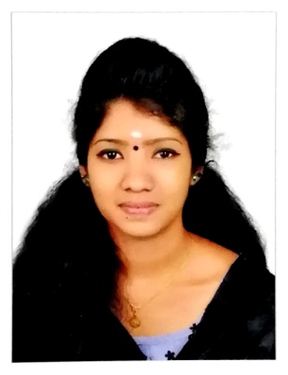
GREESHMA C.
CHOOZHIKKATTIL HOUSE
MULANHUR P.O.,
OTTAPPALAM, PALAKKAD.
PIN 679 511, KERALA
Mob: +91 70342 23749

OBJECTIVE
To associate with an organization that can fully tap my potentials and thereby to turn as an asset to the company I work for.
EDUCATIONAL QUALIFICATION
- Plus Two (Under Board of Secondary Education, Govt. Of Kerala – INDIA)
- S.S.L.C (Under Board of Secondary Education, Govt. Of Kerala – INDIA)

SKILL SET
- SALE STAFF
PROFILE
- A good team player adaptable to any working atmosphere, with grasping ability, amicable and sincere attitude to work.

LANGUAGES KNOWN
- To speak ---- English, Malayalam, Tamil

- To read ----- English, Malayalam, Tamil.

- To Write ---- English, Malayalam, Tamil

EXPERIENCE
- One year experience in sales staff in wedding lacha Section at Jayalakshmi Silks, Thrissur
- One year experience in sales staff in Ladies section at Safari mall Sharjah
- Currently works as sales staff in wedding lacha section at Pulimoottil Silks, Thrissur.

PERSONAL DETAILS
Date of Birth : 16.06.1999
Sex : Female
Father's Name : Balakrishnan
Mother's Name : Sumathi
Marital Status : Single
Nationality : Indian
Religion : Hindu
Hobbies : Reading, Travelling...
Permanent Address in India : Choozhiyattil House
Mulanhur P.O, Ottappalam
Palakkad - 679 511, Kerala

Thanks for going through my C V, and also I am anticipating an early fruitful reply from your generous end.
Yours Faithfully,
GREESHMA C.

Date:

