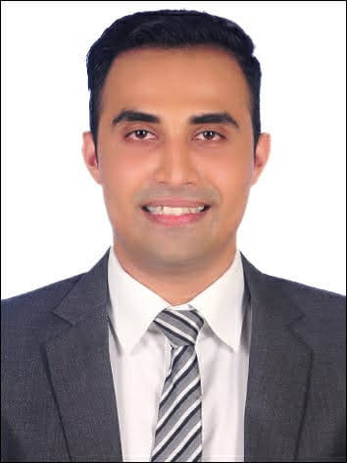***JACKSON CRASTO***

***Personal details***

***Gender: Male***

***Nationality: Indian***

***Date of Birth: 29/07/1988***

***Phone #:+971522205391***

***E-mail: jackson.c88@gmail.com***

***Languages: English (fluent) Hindi (native) Marathi (fluent) Konkani (fluent)***

***Address: 1504, B block Aliya tower, Near Freshspot Al Nadha Sharjah UAE.***

***Education Credentials & Courses***

* ***Bachelor of Arts in 2013.***
* ***Medical First Aid at Naval Maritime Academy - India (01/2011 - 02/2011)***
* ***Personal Survival Technique at Naval Maritime Academy - India (02/2011)***
* ***Fire Prevention & Fire Fighting at Naval Maritime Academy - India (02/2011)***
* ***Personal Safety & Social Responsibility at Naval Maritime Academy - India (01/2011)***

***PROFESSIONAL EXPERIENCE***

***Organization’s name: J.P. MORGAN CHASE INDIA***

***Destination: Specialist II IN Fraud & Risk Management.***

***Duration: April 30, 2019 – October 29, 2021***

* ***Handling all customer complaints efficiently and courteously, ensuring every customer received the most prompt, impeccable customer service possible.***
* ***Representing the brand in a professional manner and assisting customers with genuine care while upholding high company standards and procedures at all times***
* ***Review and handle customer’s account curb fraud***
* ***Interacting with different SME’s & Quality & training team to review and study requirement and its impact on business***
* ***Trained new team member (OJT).***
* ***Handling Team***
* ***Provided exceptional customer service and support and excellent in sales***

***Organization: Spice Jet India***

***Designation : Cabin Crew***

***Duration : 05/2015 - 05/2018***

* ***Providing a friendly and professional service to the guests, always striving to meet and exceed their expectations within a safe cabin environment, so they can leave the aircraft happy.***
* ***Answering any queries and solving any problems that arise, ensuring I stay calm under pressure and adapt to the environment, staying consistent in my service delivery.***

***Organization: Tech Mahindra Business Services***

***Designation : Senior Customer Service Associate***

***Duration : 08/2013 - 11/2014***

* ***Worked in Customer service for Three UK -Hutchison 3G UK***
* ***Company deals with telecom service my profile was to handling customer issue related to account Exceeding customer expectation and meet sales target.***

***Organization: Intelnet Global Services PVT (Barclay Credit Card)***

***Designation : Senior Customer Service Executive***

***Duration : 06/2007 - 12/2010***

* ***Communicating information and best practices with fellow team members to create a cohesive and strong working team.***
* ***Being flexible to any duties asked of me, striving to support all team members and please customers to build long term brand loyalty. Exceeding customer expectation and meet sales target.***

***SKILLS & COMPETENCIES***

* ***Able to communicate well with others; experience working with people from many different cultures and backgrounds; always able to maintain a friendly and courteous manner; able to remain calm under pressure and work efficiently in stressful situations; energetic and passionate about my work with a genuine care for people.***
* ***Excellent communication and interpersonal skills good with team handling and excellent with sales***