**ANUROOP.T**

**Kalluvila Padinjattathil,**

**Punthalathazham,**

**Kilikoloor P. O ,**

**Kollam.**

**MOB. 8129405680**

E-mail:[anuroop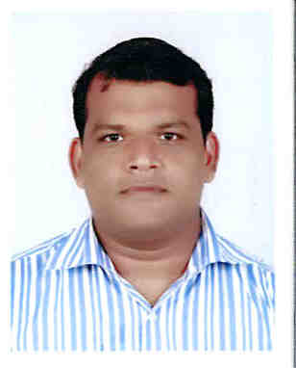**t**hankappannair@gmail.com](mailto:anuroop#thankappannair@gmail.com)

**PERSONAL SKILLS :** A pleasing personality having good confidence, communication skills and adaptable to change quickly.

**OBJECTIVE :** To utilize my potential to the maximum where I am contributing my skills in an efficient manner that will enable organizational success.

**WORK EXPERIENCE**

**Last Worked in Tober four Uniform as an Sales Manager in Trivandrum to Cochin**

**(2019 January to August)**

Two years work Experience **Fazt Lorry Transporter** as an Business Devlopment Manager in Trivandrum to Cochin.(2016 December to 2018 December)

Three Years work Experience in**H**.**D.F.C. LIFE INSURANCE as *Business Development***

***Manager in cochin***

(2013 April to November2016)

Two years and four months work Experience in ING **LIFE INSURANCE** , Cochin as

**SeniorSalesOfficer**

(2010July to2012Nov)

One and half year work experience in **RELIANCE CAPITAL SERVICE** Cochin as

***Sales Officer***( 2009 January to 2010 June)

Two years work experience in **TATA TELE SERVICES COCHIN,** as

***Senior Sales executive***

(2007 November to2009December)

Two years work experience in **RELIANCE INFOCOMM**, Cochin as ***Sales Executive***

(2005 September to 2007 October)

**ACADEMIC QUALIFICATIONS:**

* BA Degree – University of M.G (2002 to 2005)
* One year Computer Diploma in MS Office

**ACHIEVEMENTS:**

* **Received Best Performer Award from Reliance, March 2005**

**COMPUTER KNOWLEDGE**

* MS – Word, MS-Excel etc.
* General Awareness in Computer

**Personal Details:**

Name : Anuroop.T

Date of Birth : 20-05-1980

Nationality : Indian

Religion : Hindu

Sex : Male

Marital Status : Single

Hobbies : Reading books, Playing chess and Football

Languages Known : English, Malayalam & Hindi

**DECLARATION**

I hereby declare that all the above information regarding myself is true and correct to the best of my knowledge and belief.

Place:Kollam

Date:13/5/2020