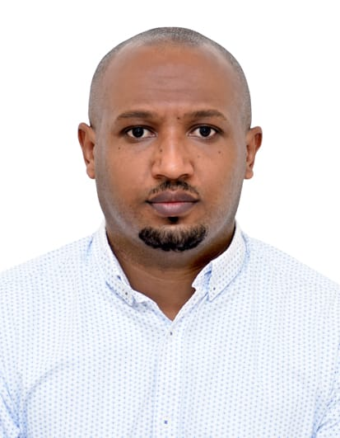 **FITSUM TEGEGN**

Email**:** [**Yehagerlej.t@gmail.com**](mailto:Yehagerlej.t@gmail.com)

Contact Number: **+971567580648**

Nationality: **Ethiopian**

**Objective** 3 Years of experience as sales supervisor is seeking to obtain a career in customer service relation to utilize my professional experience & skills to become a great asset in a fast pace, growing company or corporation. I would enjoy a challenging role where I could offer my considerable sales capabilities and service delivery experience. In my previous Supervisory roles I maintain a highly visible and hands on role while promoting dedication, team work, and superior customer service.

**Educational Qualification**

* Information Technology, Diploma
* Electronics maintenance, Advanced certificate

**Special Training**

* Customer Services
* Fashion and Terminology
* Pint of sales device and consolidation
* BPR (Business Process Reformation

**Professional work Experience**

**DUBAI HOLDING GROUP Abu Dhabi, U.A.E**

**SFERA January 2018- December 2020**

**Position: Sales supervisor**

**Job Responsibility:**

* Ensure merchandise is clean and ready to be displayed
* Maintain inventory and ensure items are in stock.
* Ensure promotions are accurate and merchandised to the company’s standards.
* Monitor local competitors.
* Maintain store's cleanliness and health and safety measures.
* Organize and distribute staff schedules.
* Help retail sales staff achieve sales targets.
* Handle customer questions, complaints, and issues.
* Coach, counsel, recruit, train, and discipline employees.

**DUBAI HOLDING GROUP Abu Dhabi, U.A.E**

**SFERA November 2014- December 2017**

**Position: Sales Associate**

**Job Responsibility:**

* Drive sales through engagement of customers, suggestive selling & sharing product knowledge
* Greets and receives customers in a welcoming manner
* Assists with inventory, including receiving and merchandising new goods
* Processes payments by totaling purchases, processing checks, cash, and store or other credit and debit cards
* Analyzing opportunities by researching the industry and market trends
* Maintaining relationships with larger clients by providing information, support and guidance

**GIO-FERRARI BTC FASHION GROUP Dubai, UAE**

**November 2012 –October 2014**

**Position: Sales Associate**

**Job Responsibilities**

* Greeted customers with a friendly and helpful attitude.
* Processed cash and credit payments rapidly and accurately.
* Answered any questions regarding inventory, sales, and promotions.
* Worked well with other employees to ensure smooth processes.
* Effectively understand and implement all company policies in the store  
  especially concerning exchange and refunds, process transactions fast and  
  accurately.
* A team player who can work easily with different Nationalities and can fit in  
  any working environment.

**Champion sportswear shop Addis Abeba, Ethiopia April 2008– march 2011**

**Position: Sales Assistant**

**Job Responsibilities**

* Sells sporting goods and athletic equipment: Advises customer on type of equipment for specific purposes, such as length of golf club, size of grip on tennis racket, weight of bowling ball, length of skis and poles, and caliber and make of gun or rifle.
* Explains care of equipment, regulations of games, and fish and game laws.
* Informs customer of areas for hunting, fishing, or skiing, and cost of such outings.
* Performs other duties as described under SALESPERSON Master Title.
* May repair sporting goods.

**Skills and Competencies**

* Establish courtesy and professionalism at the workplace
* Excellence in customer care services
* Goal oriented, outgoing and with positive motivation in life
* Team player, able to work in collaborative setting
* Trustworthy and very systematic in handling people and job assignments and practicing leadership skills
* Has the ability to effectively interact in both oral and written strong communication
* Willing to undergo training and learn new trends and system implemented

**References Mr. Del Pierro**

**Declaration**

I declare that the information provided above is true and correct to the best of my knowledge.