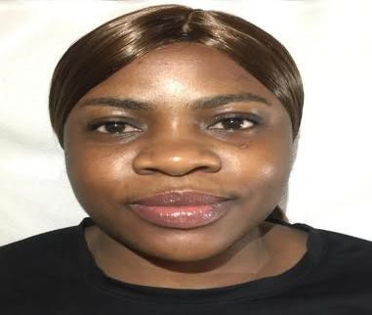

***I***

***GBINOSUN***

***E***

***M***

***ILY***

***UYINM***

***W***

***E***

***N***

*Address*

*:*

*Dubai*

*Marina,*

*JVC,*

*U.A.E.*

*Mobile*

*No:*

*0547618741*

*(*

*WhatsApp*

*)*

*Em*

*ail*

*add*

*:*

*i*

*gb*

*i*

*no*

*s*

*un*

*e*

*m*

*il*

*y*

*@gma*

*il*

*.*

*c*

*o*

*m*

**Car**

**ee**

**r**

**O**

**bj**

**e**

**c**

**t**

**i**

**v**

**e**

To contribute in growth and profitability of the organization by providing efficiently to all internal and external customer and to ensure smooth and uninterrupted functioning of work by ensuring availability of right quality of services (in terms of services).

# Work Experience

❖ Jide taiwo & Co. Property Link real-estate

Legos Nigeria

2018 to 2020

# Skills

* Have a good knowledge of English to communicate with customers.
* Strong ability to handle the work pressure.
* Very good management skills.

# Academic Qualification

* Igbinosa high school 2001-2007
* College of Education, Benin City, Edo state, Nigeria

|  |  |
| --- | --- |
|  | **Personal Information** |
| ❖ Nationality | : Nigerian |
| ❖ Date of Birth | : 23/11/1987 |
| ❖ Religion | : Christian |
| ❖ Marital Status | : Single |
| ❖ Languages | : English |
| ❖ Visa Status | : Tourist visa |
|  | |

* Passport No : A10163737 ❖ Expiry Date : 21/07/2021