BIO-DATA

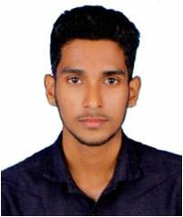
joji shabu

Roadvila Veedu
Edamulackal P.O
Anchal Kollam (Dist), Kerala
India, Pin : 691306
Mob :+91 7907946788
Email : jojishabu007@gmail.com

:: PERSONAL PROFILE:
Father’s Name : shabu. G
Sex : Male
Date of Birth : 26/06/1995
Marital Status : unmarried
Religion : Christian, Catholic
Nationality : Indian
Mother Tongue : Malayalam
Languages Known : Malayalam, English & Hindi
:: EDUCATIONAL QUALIFICATIONS:

- SSLC -- govt. Hss Edamulackal
- Plus Two - KPMS Cheriyavelunnaoor
- Degree - st. John’s College, Anchal
- Account - Corporate Accounts, Kottarakkara

::computer knowledge:
- DCA  Software Computer, Anchal
- Tally - Corporate Accounts, Kottarakkara
:: experience details:

- Asst. Accountant, Corporate accounts (2019)
- Billing and office work at Panavila agency (Electrical and Hardware shop), Anchal (2021-)
:: passport details:

Passport No : S4169183
Date of Issue : 04/09/2018
Date of Expiry : 03/09/2028
Place of issues : Trivandrum

:: DECLARATION:

I hereby declare that the above mentioned information is correct to best of my knowledge and belief. I bear the responsibility for the correctness of the above mentioned particulars.

Place : Edamulackal
Date : joji shabu

