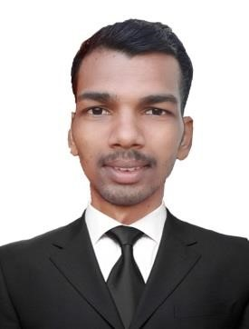

**CURRICULUM VITAE**

**ChandraVamshi Ponna**

**Mob.: +971 567703593**

**E-mail:** [**ponnachandravamshi@outlook.com**](mailto:ponnachandravamshi@outlook.com)

**Dubai, U.A.E**

**APPLICATION FOR: STORE KEEPER&**

**Objective:**

Intend to build a career with the leading corporate of hi – tech environment with committed and dedicate people, which will help me to explore myself fully and realize my potential. Willing to work as a key player in challenging and creative environment.

**Skills:**

* Able to work individually and as team.
* Hard working committed and result oriented capable of working independently.
* Accommodative attitude blended with keen sense of responsibility and leadership and willing to learn.
* Effective organization skills with planning, coordinating and leadership and controlling capabilities.
* Able to work under pressure with minimal supervision.

**Work Experience**:

**Company: Ejadah Asset Management LLC Dubai, U.A.E.**

**Position: Cleaner & Office boy**

**Location : JBR**

From Sep 2019 to Till date.

**Duties & Responsibilities**:

* To come on duty with complete uniform and well groomed.
* Check / clean the designated section.
* Replace any soiled linen to fresh one.
* Complete all the amenities in the area.
* Check and report / follow up any maintenance while on duty.
* Report any lost and found in the section.
* Check / maintain / order flower for the toilets.
* Follow team leader / manager instruction related to work.

**Education Qualification:**

* Post Graduation Diploma in Computer Applications
* 10th Passed
* +2 Passed

**Personal Profiles**:

Name : **Chandra Vamshi Ponna**

Date of Birth : 12-05-1999

Nationality : Indian

Gender : Male

Marital Status : Single

Languages Known : English , Hindi & Telugu

**Passport Details**

Passport No : T6911897

Date of Issue : 09-08-2019

Date of Expire : 08-08-2029

Visa Status : Employment Visa

**Conclusion & Declaration:**

I hereby declare that the above details furnished by me are true to the best of my knowledge and belief.

**Place:** Dubai  **ChandraVamshi Ponna**