**SHANU SUNNY**  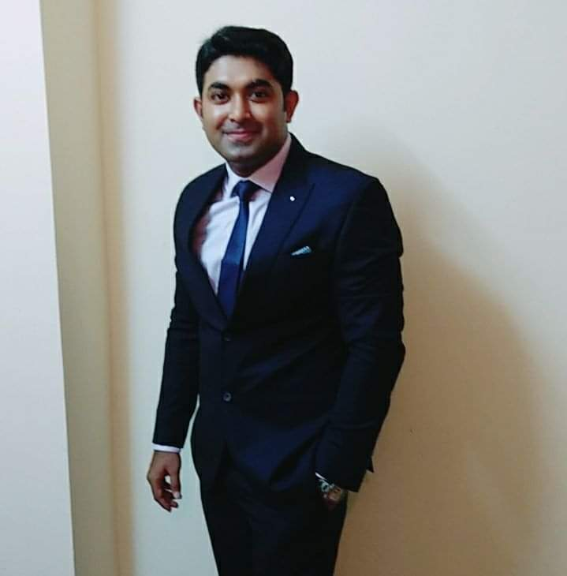

**CONTROL & INSTRUMENTATION Engineer - KEPCO KPS**

shanu.sunny8@gmail.com

+971 528179339

+91 9795997958

Qualified electronics & instrumentation engineer (2011) with DCS Engineering & training and diploma

Certification in industrial automation (2011-2012)

Presently working in 4*1400MW nuclear power in UAE as a I&C Maintenance Engineer.

Competent professional over 7+ years of enriched experience in Erection, Testing, commissioning & maintenance in PF Boiler by Alstom, siemens Turbine, and DCS (maxDNA) in Thermal Power Plant.

3 X 660 MW PPGCL (JAYPEE GROUP), ALLAHABAD as Sr Engineer C&I.

-Have Assist with PLC & SCADA using ALLEN BRADLEY PLC- RS logic 500, SIEMENS PLC-S7400 and designing

SCADA on intouch &WINCC, GEFANUC PLC-SIMPLICITY, HMI, HYDRAULICS

Adept in carrying out complete plant system including installation & commissioning of various Field

instruments, TSI system, DCS logics and HMI Graphics for Boiler and Turbine auxiliaries.

Consummate professional with hands on exposure to General Management, various engineering

documents like P&IDs, data sheets & specifications of instruments, Loop Drawings, Logic Diagrams, GA

Drawings, Cable schedule, I/O schedule, Check list and Commissioning Procedures etc.

**Work Experience**

**Maintenance Engineer (Control & Instrumentation)-KEPCO KPS**

Barakah Nuclear power plant ,Abu Dhabi,UAE

**March 2021 to Present**

(unit#01- successfully generating power ,unit#02-under testing,unit#03-79% erection commissioning done,unit#04 under erection & commissioning).

**RESPONSIBILITIES**

Installation, testing and Commissioning of I&C instruments with proper procedure.

Calibration,preventive maintenence,corrective maintenance of field instruments such as Rtd,Tc, Pressure switches, transmitters and gauges, flow transmitter,

level transmitters and switch, Temperature gauge and switch,Conductivity sensor,ph sensor etc.

Quintessential Professional with hands on General Management, various engineering

documents like P&IDs, data sheets & specifications of instruments, Loop Drawings, Logic Diagrams, GA

Drawings, Cable schedule, I/O schedule, Check list and Commissioning Procedures etc.

Performing activities for successful completion of all tasks including CAT and Punch List activities etc on time

with quality and safety

**Sr.Engineer (Control & Instrumentation)**

- **PPGCL (Renascent Power, a subsidiary of the Tata Power**.**)**

Prayagraj, Uttar Pradesh

**August 2012 to March 2021**

ALLAHABAD (U.P), INDIA

Designation: Sr. Engineer (Control & Instrumentation)

Area of supervision: DCS (maxDNA 4F & sppa t3000 seimens turbine dcs),

BTG (PF Boiler, BHEL make)

BOP(Thermax make)

**RESPONSIBILITIES**

Installation, testing and Commissioning of DCS (maxDNA), Redundant Network system, Engineering

and operators work stations, Turbine stress controller, Unit control panels and GPS master/slave clocks.

➢ Knowledge of DCS configuration uploads & downloads to controllers, DPU flashing, Sequence of

event and alarm generation, DCS trends generation and field Input/output signals troubleshooting.

➢ Exposure to DCS control logics (permissive & interlock) for boiler & turbine auxiliaries, HT/ LT Drives

and breakers, process control loops and make changes to meet the system reliability and protect

frequent shutdown.

➢ Hands on experience of TSI probes (Make Megitt India & Shinkawa) installation and commissioning, Governing

Valve (Make Rexroth) and HP/LP bypass system (BHEL/Bomafa make) Commissioning.

➢ Commissioning and maintenance Of Integral/Non-integral MOVs (make auma, Limit torque and

Rotork, Flowserve), Pneumatic actuators (Mil, ABB, Frobes Marshall), Gate and dampers, Burner tilt Power

Cylinders, KGVs and Solenoid valves.

➢ Commissioning & maintenance of instruments associated with FSSS, SADC, Gravimetric Feeders

(BHEL make) and TG system (BHEL make) as per P&IDs and standard manuals.

➢ Conduct regular troubleshooting and root cause analysis of any failure Of Field instruments,

Analysers etc.

➢ Erection & commissioning of field instruments associated with HT/LT drives like BFP, CEP, ID, FD, PA,

Scanner air Fan (DC/AC), Seal air Fans, Coal Mills, Mill reject System, CW/DMCW pumps, CT fans etc.

➢ Commissioning of SWAS analysers, Soot blowing system, Chemical dosing system, ERV, FTP, Bunker

level monitoring system, CEMS, Opacity, O2, CO analysers

EPC Work & Technical Background:

➢ Successfully synchronized 3X660 MW TPP projects which include DCS logic and maxVUE HMI

graphics creation for boiler and turbine auxiliaries, System wise commissioning Protocols Checking, LIE/

LIR location plans etc.

➢ Calibration of field instruments such as Pressure switches, transmitters and gauges, flow transmitter,

level transmitters and switch, Temperature gauge and switch etc.

Review of basic engineering documents like DCS signal flow diagram, instrument data sheet and

specifications, calculation and bill certification of contractors (BHEL & PLL) etc. Control all contractors

performance for successful completion of all tasks including NCR and Punch List activities etc. on time

with quality and safety

➢Attending of daily defects which are raised by operation dept on SAP (SYSTEM ANALYSIS PROGRAM) for smooth & uninterrupted functioning of all units.

**Exposure to:**

➢ DCS Interface: maxDNA 4F (M/s BHEL), C 300 (M/s HONEYWELL), ABB 800 xA.

➢ PLC Interface: (M/s Allen Bradley, Schneider, Rockwell)

➢ Calibration: TSI probes, Temp &Pressure switch, Gauges, Flow Transmitters, Level Transmitter,

Gauges, etc.

➢SAP (SYSTEM ANALYSIS PROGRAM) PM Training.

➢ Analysers : O2, CO, SPM, Silica, Conductivity, pH

➢ Vibration Monitoring System: (M/s Megitt India, Mechanalysis, Frobes Marshall & Bently Nevada)

➢ MOV: Integral/ Non-Integral (Auma, Rotork, Limit torque make)

➢ Control valves: MIL, Frobes Marshall, ABB, Smart/ Non-smart Positioners, Sampson etc.

➢ PID Tuning, Boiler and turbine control systems, Sub group control and BHEL make governing system.

➢ ISA Standards, KKS tagging, P&IDs, Hook-up Drawings, Power plant control loops (OLCS, CLCS)

**Education**

**B. Tech in Applied Electronics & Instrumentation in Applied Electronics &**

**Instrumentation**

Rajiv Gandhi technical university - Bhopal, Madhya Pradesh,India

2007 to 2011

**Skills**

Allen Bradley (5 years), Excel (Less than 1 year), GE PLC (5 years), MS word (Less than 1 year), turbine

(7years), MaxDNA (7+),SAP PM MODULE(7 MONTHS)

**Additional Information**

**IT SKILLS**

**COMPUTERLITERACY**:

❖ Advance MS word, Excel, Powerpoint, o/s:windows

❖ PLC software: Allen Bradley-RS Logix 500

❖ SCADA software: in touch (wonderware)

❖ maxDNA bhel (dcs for balance of plant operation)

❖ sppa t3000 (seimens turbine dcs)

**Personal Information**

Date of Birth : 5th January 1990

Gender : Male

Religion : (Catholic) Christian.

Marital Status : Married

Nationality : Indian

UAE ID : 784-1990-4136828-5

Passport no : M1784751

Passport validity : 07/10/2014 -06/10/2024

Parmanent Address : Parambil puthen purayil house,Charummood Post Office,

Kerala ,India pin-690505

Languages Known : English ,Hindi,malayalam