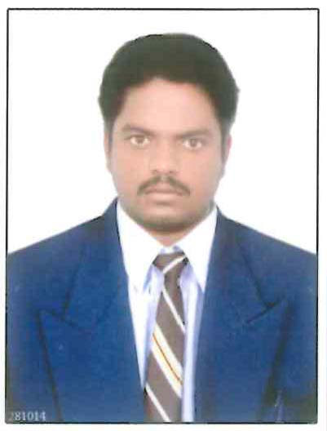

CURRICULUM VITAE

PADIGEL SRAVAN KUMAR

Sravanpadigel87@gmail.com
Mobile : +973 36508541

CAREER OBJECTIVE:

- As A SAFETY Engineer with Electronics and Communication background to build an excellent career in a fast growing safety environment by offering the best of my talents in the field of Health, Safety & Environment in an effective manner and utilize my knowledge and qualifications as a skilled HSE professional where am present.

EDUCATION:

- B.Tech (Bachelor of Technology) in Electronics & Communication Engineering 2011
- Intermediate from Board of Intermediate.2007
- SSC from Board of Secondary Education. 2005

PROFESSIONAL CERTIFICATION:

- Diploma in Fire and Safety
- NEBOSH (Health, Safety at Work)
- IOSH-Managing Safety
- Professional Certificate Course in Construction Safety
- Professional Certificate Course in Oil & Gas Safety
- Professional Certificate Course in Electrical Safety
- Professional Certificate Course in Confined Space Entry

COMPUTERS SKILLS:

- Hardware and Networking
- Ms - Office (Ms-word, Excel and Power point)
OTHER PROFESSIONAL TRAININGS

- Contractors Basic Safety Training Course.
- Permit to Work Training
- Basic Fire Fighting Training.
- Work at Height.
- Scaffolding Safety
- Vehicle inspection
- LOTO (LOCK OUT TAG OUT)

PROFESSIONAL EXPERIENCE:

- Previous working as Safety Supervisor in Bgtc in Al zoor Refinery project in Kuwait 15/05/2018 to 20/01/2019
- Previous working as Safety Officer in Ocean International General Trading Contracting Co. in KUWAIT 08-06-2017 to 07/05/2018
- Previous working as Safety Supervisor in BPCL at Mumbai oil and gas refinery in India 22-11-2013 to 15-01-2017
- Previous working as Safety officer in Nagarjuna oil and refinery limited in India 10-01-2012 to 20-08-2013

Areas of Expertise

Safety Management System
- Developing effective procedures for implementation of safety programs for construction projects.
- Formulating & administering safety measures and risk assessments to prevent accident / incident, plant/property damage.
- Ensuring documentation of MSDS of all Toxic & Hazardous materials are in compliance to safety standards.

Inspection & Testing
- Vehicle Inspection and Fire Extinguisher Inspection daily.
- Carrying out inspection tests for determining the effectiveness of the equipments/ plants keeping in view the performance, safety standards.
- Conducting safety audits and managing day-to-day safety performance to ensure that activities conform to the industrial safety standards.
- Investigating accidental cases and reporting the same to the management; ensuring prevention of future accidents.

Training & Development
- Organizing campaigns, training (Fire Fighting & Rescue, First Aid, etc.), contests and other activities to enhance their operational efficiency leading to increased safety awareness & productivity.
- Identifying and implementing strategies for building team effectiveness by promoting a spirit of cooperation between team members.

Roles & Responsibilities:
- Major activities like implementation of management safety policies, site safety induction, regular safety inspections, conducting training and safety meetings very frequently.
- Providing safe access/egress to the employees at all work sites.
- Develop and present safety training modules, includes safe lifting operations, signal/Banks man and rigging.
- To check condition of PPEs at regular intervals.
- To develop a method to motivate staff and labors to get encouraged by obeying more and more safety rules.
- Provided administration, Counseling and guidance, from the workers to corporate level and have multi faced exposures in planning and projects Development
- Co-ordinate with Safety Engineer regarding the implementation of plant related safety matters in the organization.
- Managing fire extinguisher program, ensure regular inspections, maintaining good housekeeping etc.
- Management of work place safety, Safety induction.
- Implementation of Management Safety Policies, Barricades, Sign boards, P.P.E., etc,
- Providing Safe Access/ egress to all the employees.
- Assist Management in developing and implementing their HSE plans and advice on operational safety matters related to the works.
- Give safety presentation with the objective to enhance the Health, safety and Environment awareness of all workers.
- Conducting Safety Training/ Tool Box and Mass TBT Talks at regular basis.
- Responsible for ensuring safety during the construction of buildings & successfully completed the following projects in safest manner.
- Conducting regular safety inspections, Hazard spotting exercise.
- Strictly following PTW system.
- Safety Implementation at Columns, Steel Erection Works.
- Implementing Electrical Safety, Hot Work Safety, Etc.

PERSONAL PROFILE:

Name : PADIGEL SRAVAN KUMAR

Father’s name : PADIGEL SAYANNA

Date of Birth : 10-05-1989

Nationality : INDIAN

Marital Status : MARRIED

Languages Known : ENGLISH, HINDI, and TELUGU.

Driving License No : Valid Indian Light duty Driving License
Lic. \no. AP02520130005912

Passport Details : No: V1348568
Issue DT: 02-07-2021
Expiry DT: 01-07-2031

Date:
Place:Bahrain
(P.Sravankumar)

