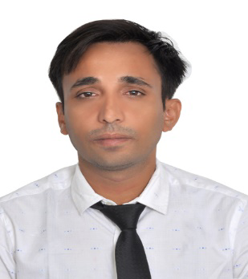**Md. Asif Iqbal**  
Email: [asif39089@gmail.com](mailto:asif39089@gmail.com)   
Mobile Number: - +971 -583018797

Visa status: - Visit Visa (Available for immediate join)

**Area of Interest: - Indoor/Outdoor sales**

**Career Objective: -**

“**Highly motivated sales professional** seeking a sales representative position, where I can contribute my strong customer service and negotiation skills. I bring five years of retail sales experience.

**Work Experience: -**

* 5+ Years of experience in the field of Sales and marketing including more than 3.5 years of Saudi Arabia work experience.

**Job Profile: -**

* Previous Organization : **Aﬂa al khaleej . Sanitary Ware in Saudi Arabia**
* Designation : **Sales Representatives**
* Duration : **May 2016 to Oct 2019**

**Roles & Responsibilities: -**

* Generating leads and providing information to team members.
* Meeting or exceeding sales goal regularly.
* Negotiating all contracts with prospective clients.
* Helping determine pricing schedules for quotes, promotions, and negotiations.
* Preparing weekly and monthly reports.
* Giving sales presentations to a range of prospective clients.
* Coordinating sales efforts with marketing programs.
* Understanding and promoting company programs.
* Obtaining deposits and balance of payment from clients.
* Preparing and submitting sales contracts for orders.
* Visiting clients and potential clients to evaluate needs or promote products and services.
* Maintaining client records.
* Answering client questions about credit terms, products, prices, and availability.

**Previous Organization: -**

**Jayanti Food and Beverage: - (New Delhi, India)**

* I was working as a sales representative (January 2015 to April 2016)

**Tech Mahindra: - (Kolkata,West Bengal) India**

* Worked as Customer Support Executive (December 2011 to February 2012)

**Responsibility: -**

* Handles incoming calls or inquiries from prospective customers or clients.
* Assists customers effectively by solving customer disputes.
* Provides customer additional information or explains services.
* Discusses products offered and ensures customer satisfaction.

#### **Academic Qualification: -**

* Completed MBA from Sikkim Manipal University in 2014
* Completed BBA from Sikkim Manipal University in 2010
* Central board of secondary Education (CBSE) 2005- 2007

**Personal Details: -**

Date of Birth- Jan-03-1990

Nationality- Indian

Language known- English, Hindi, Urdu

Passport Number- K5445912

Driving License- Holding Driving License for Saudi Arabia

**Declaration**-: I hereby declare that all the above particulars furnished by me are correct and true to my knowledge and belief.

**Date & Place: - *Md. Asif Iqbal***