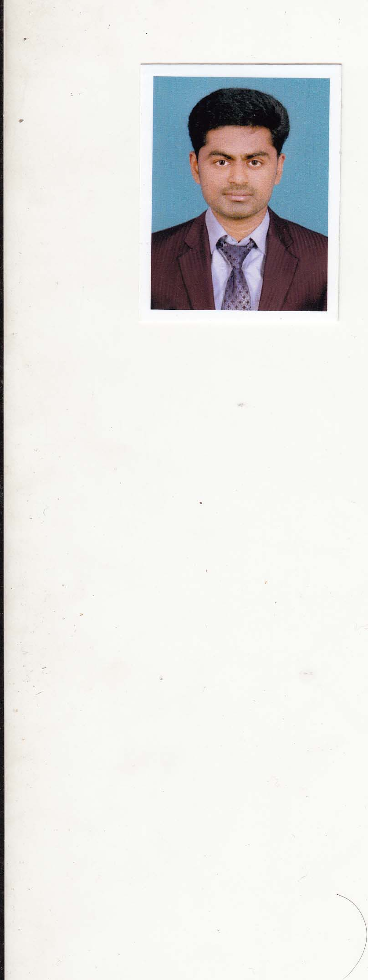 **CURRICULUM VITAE**

**JACOB EMILIAS**

Pankajam Veedu,

Kurukkan Vilakam,

Meppattumala, Valiyara,

Vellanadu P.O, Trivandrum

Kerala, India.

Mob : +919061366716,

+918848931317

Email : [e.aneeshvld@gmail.com](mailto:e.aneeshvld@gmail.com)

**CAREER OBJECTIVE**

To contribute and participate in the growth of your esteemed organization by making a career which provides a challenging work culture and opportunities to work for the fullest extent.

**ACADEMIC QUALIFICATION**

* (2003) S.S.L.C in Government VHSS, Vellanad, Trivandrum.
* (2004-2005) Science in Government VHSS, Paruthipally, Trivandrum.

**PROFESSIONAL QUALIFICATION**

* Diploma in Hotel Management from the Chavara Institute of Management Studies, Vazhuthacaud, Trivandrum.

Duration : August 2005 to July 2006

Score : 80%

**SUMMARY OF SKILLS AND EXPERIENCE**

Under went training (O.D.C) the Food & Beverage service department at (banquets LEELA PALACE from 12.10.2005 to 22.10.2005.

Attended weekend outdoor catering in several areas in and around the locality

**INDUSTRIAL TRAINING**

Six months industrial training in F&B Service from the Horizon Hotel Trivandrum from 15.09.2006 to 22.03.2007.

**H.O.T TRAINING**

3 months worked as a HOT (Hotel Operation Trainee) in F& B Service.

Department of Hotel Horizon Trivandrum, Kerala.

**EXPERIENCE**

* Two year working in **Uday Samudra, Leisure Beach Hotel** , Kovalam, TVM

Designation : Waiter

Duration : October 2007 to August 2009

* Two year four month working in Hotel **Trinity ISLE** Seshadripuram, Banglore.

Designation : Sr. Waiter

Duration : feb 2010 to july 2012

* One year and 3 months Working in **Hotel Gokulam Park** Ernakulam Kaloor.

Designation : Trainee Team Leader

Duration : sep 2012 to januery 2014

**.** Hycinth by Sparsa, Trivandrum (Automatric Hotels Pvt.Ltd) A five Star Business Hotel Coith 104 Rooms and four F&B Out lets.

Designation : I R D Team Leader

Duration : 5th June 2014 to 30th September 2014

**.** Two years working in Golden tulip althanyh Hotel tecom, dubai,U A E**.**

Designation : waiter

Duration : 28/11/2014 to 25/11/2016

**.** Presently working in Elixir hotel ( 5 STAR ) and resort munnar,idukki

Designation : F & B Team leader

Duration : 2nd feb 2018 to till

**SKILLS AND KNOWLEDGE**

**Co-ordination**

Adjusting action in relation to others actions.

**Time Management**

Managing ones own time and the time of others.

**Service Orientation**

Actively Looking for ways to helps people.

**Active Listening**

Giving full attention to what other people are saying, talking time to understand the point being made asking questions as appropriate, and not interrupting at inappropriate time.

**Speaking**

Talking to others to convey information effectively.

**Customer & Personal Service**

Knowledge of principles and processes for providing customer and personal services. This includes customer needs assessment, meeting quality standards for services, and evaluation of customer satisfaction.

**PERSONAL DETAILS**

Father’s Name : Emilias

Date of Birth & Age : 15-06-1988, 28 Years

Religion : Christian

Nationality : Indian

Sex : Male

Marital Status : Married

Languages Known : Hindi, English & Malayalam

Hobbies : Sports, Painting

**PASSPORT DETAILS**

Passport No : H2039993

Place of Issue : Trivandrum

Date of Issue : 01-12-2008

Date of expiry : 30-11-2018

**COMPUTER SKILLS**

Windows, Computer Basics, Ms office, Internet.

**COMPUTER BILLING**

WINHMS Software, Microsoftware, Hot Software.

**DECLARATION**

I hereby declare that above said particulars true and correct to the best of my knowledge and belief.

Date :

Place : **JACOB EMILIAS**