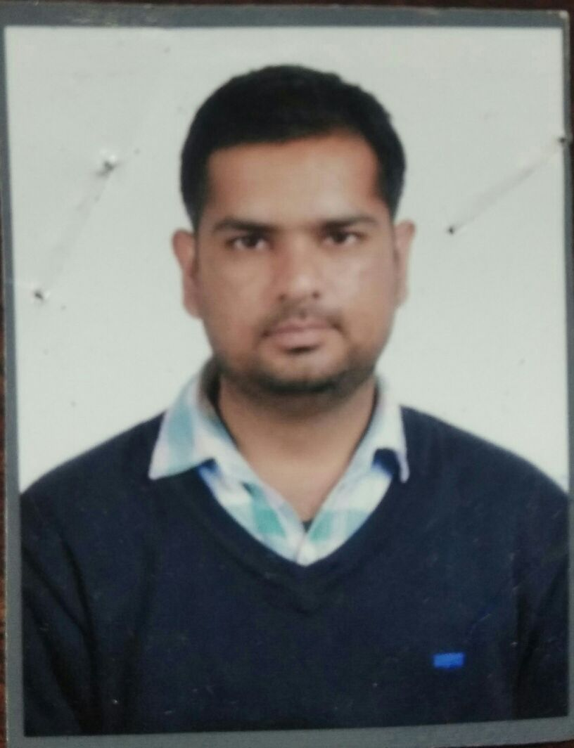
CARRICULAM-VITAE

Degree in Electronics & Communication Engg. from Kurukshetra University , Kurukshetra.  Permanent Address  Kanwar Tarif  H.NO.145/11 Railway Gate,Rabarian Mohalla  Distt- Kaithal [Hry.]  ResidentialAddress  Kanwar Tarif  H.NO.145/11 Railway Gate,  Distt- Kaithal [Hry.]  PIN- 136027  E-Mail:  Kanwar.tarif27@gmail.com  Contact No:  Cell: 07087175028  Personal Information  Name: Kanwar Tarif  Father Name: Sh. Brij Lal  Date of Birth: 01.04.1986  Sex: Male  Nationality: Indian  Martial Status: Married  Language: English, Hindi,Punjabi  Hobbies:-  1) Decisive man  2) Making Friends.  3) Listening music.  4) Singing.  5) Travelling.  6) Swimming . | Objective  To explore new dimensions in my profession with progressive contributions towards overall growth of the company in corporate world with zeal to excel.  Qualifications  - Professional Qualifications:-  • Degree in Electronics & Communication Engineering from Kurukshetra University , Kurukshetra [Hry.] with first class in the year of 2011 .  - Academic Qualifications:-  • 10 th: from Govt. Sr. Sec. School, kaithal with first class in the year of 2004 (H.B.S.E.).  • 12th: from Govt. Sr. Sec. School, kaithal with first class in the year of 2006  (H.B.S.E.).  Job Profile  - Currently seeking job on the profile as an ELV-MEP Project Engineer .  - SIEMENS Ltd Gurugram year from 2018 to Jan ,2021 as Siemens Trusted vendorship and executed some reputed projects .  - SIEMENS Ltd (ICBT Divison ) Chandigarh year from 2014 to 2018 as ICT/ELV Service Engineer and deal with Fire Detection System , Building Management System, Electrial installation, ACS ,cctv, Audio-Video system,Electrical and Load Management system,GBFSS in Data Centers and other Securities that covers IBMS products etc. and new projects and service the AMCs of the project sites.Siemens Building Technology Division deals with a huge level Projects related to HVAC and Electrical Power control by BMS software .  - Beltex Engineering Services,(a System Integrator of Honeywell & Schneider Electrical) , Panchkula from 2011 to 2013 mid.  - Involve in Design, Execution,Testing and Commissioning of Building Management System ,Fire Alarm , Access Control System and CCTV Surveillances, Electronic Security System ,Data & Voice System, Drives ,AC- DC Drives etc. Electrical installation ,drawings, wiring,lighting,power, switches etc  Key Skills and Competencies in ELV –MEP Projects &Services  - Capable of handling the work of installation & commissioning .  - Able to prioritize and plan effectively.  - Can work with technicians and other support staff efficiently.  - Negociating Skills  - Good at presentation.  - Excellent customer facing and communication skills.  - Excellent to attend the Service Call and resolve the criticality at Sites  - Lead the site project Team and meet clients requirement before the schedule deadline .  - Prepare the data for Contractors and Client billing.  - Prepare BOQ & Tender filling online  Work Experience & Achievements in Projects and Services  - WalMart(Best Price), Zirkpur  - WalMart(Best Price), Meerut  - WalMart(Best Price) , Ludhiana  - WalMart(Best Price) ,Jalandhar  - WalMart (Best Price),Bhatinda  - Lakshmi Food & Energy Ltd., Khamanon (Pb.)  - Ambuja Cement, Ropar (Punjab)  - Bebo Technologies Pvt. Ltd. I.T. Park, Chandigarh.  - Civil Hospital sites under PHSC ,Pb.  - Punjab Muncipal Bhawan,Sec-35,Chd  - Punjab Udhyog Bhawan,Chd,  - IBMS projects at S.D college Sec-32,Chd.  - BMS Projects SukhVilla ,Chandigarh  - Fire Alarm system at Grandwalk Mall,Ldh.  - BMS Project of Sun Pharma, mohali  - DLF (IT Park), Chandigarh  - HPCL ,IBMS Project ,Bathinda (Pb.)  - DFCC (WDFC) Railway Project(Rewari to Kishangarh) CPT-1,2. It’s an L&T company Project in Rajasthan.  Training  - June 2009 to July 2009.  Training Title: PLC at Quick Logic Controls ,PKL.  - June 2010 to July 2010  Training Title : Network Communication at RCOMM.  Minor Project  - F M Transmitter System which sending signal of frequencies 88Mhz- 108 Mhz.  Major Project  - A DTMF based ROBO CAR which is Appreciated and Famous Project at State Level Engineering College.  Seminar Delivered  - Multichannel door Alarm With Display  - Digital Tachometer  Technical skills  - Basic knowledge of PLC, DCS, SCADA, DRIVES.  - Proficient in MS Word, MS Excel, MS Outlook.  - Proficient in Advance Excel By Microsoft Certified Course  - Windows 2000, Windows Xp, Windows 7 and Internet.  - Working knowledge on AutoCAD for drawing .  Extra Curriculum Activities  - Participated in singing competition at School Level.  - Participated in singing competition at University Level  - Participated in EFY EXPO 2011 in Pragati Madaan (Delhi)  Strengths  - Positive Attitude.  - Leadership Qualities.  - Easy going and co-operative person.  - Time Management  - Quick learner.  - Persuasive Nature  Declaration  I hereby declare that all the information provided here are correct to the best of my knowledge.  Date :  Place: Chandigarh Kanwar Tarif

