HARISH KUMAR D M  Sales Specialist | CSR | | 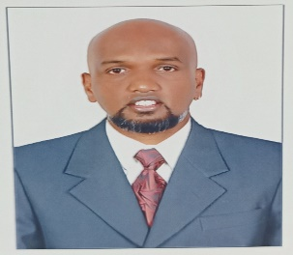
PERSONAL PROFILE:  Significant skills in all aspects of Customer Service and an experienced sales professional with superior work ethics & creative revenue generation Ideas. I pride myself on being a vibrant individual competent within the foundations of outside & Inside sales environments, possessing excellent interpersonal, communication and problem solving skills with the professional aspiration to consistently achieve more.  Expertise in both Outside & Inside Sales, Customer service Revenue Generation, Escalations,  Business development and people management, Process management & Time  management. Client management (excellent in communication with clients).  Understanding of client billing. Good in forecasting, planning and delivering. Trained on multiple International Sales modules.  WORK EXPERIENCE:  NTT DATA Global Services Pvt Ltd - Bangalore, India 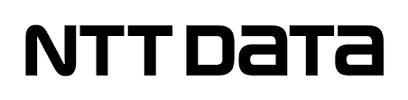  Sales Representative  August 2019 to February 2020  • Promotes/sells/secures orders from existing and prospective customers through a relationship-based approach.  • Demonstrates products and services to existing/potential customers and assists them in selecting those best suited to their needs.  • Establishes, develops and maintains business relationships with current customers and prospective customers in the assigned territory/market segment to generate new business for the organization’s products/services.  • Makes telephone calls and in-person visits and presentations to existing and prospective customers.  • Researches sources for developing prospective customers and for information to determine their potential.  • Develops clear and effective written proposals/quotations for current and prospective customers.  • Expedites the resolution of customer problems and complaints.  • Coordinates sales effort with marketing, sales management, accounting, logistics and technical service groups.  Work-Place Options - Bangalore, India 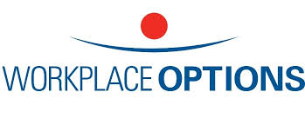  Sales Team - Inside Sales Representative - Lead Generation Specialist  Oct 2017 to June 2019  • Experience gained within the International Sales environment  • Lead generation, cold calling, email and text blast skills, product demonstration, sales and after sales relationship plus references  • Consistently achieved ARPU and MRR targets  • Handled leads right from lead generation to nurturing, demo stage, trail stage & sales closure (Including self gen of leads)  • Gained experience in Handling marketing, website request and Inbound leads  • Excellent sales conversion ratio• Worked on Sales Force (SFDC) and Outreach CRM tools  Cognizant Technology Services - Bangalore, India   Senior Voice Process Executive - Operations  August 2014 to September 2017  - Helps resolve problems with production processes or identifies inaccurate process  - Be a team player by providing required inputs on time to enable the team to process the task efficiently.  - Generating leads through direct walk in & customer references  - Monthly & Quarterly sales forecasting, planning and implementation  - Achieve business plan  - Provide full support on new businesses integration as assigned from time to time. Build relationships with key points of contact within the operation across the processes and other functions in order to maintain an understanding of the process context  - Product demonstration, site visit, government approvals, payments & billing  - Teamwork, collaboration with local electricians, laborers & government agencies  - Provide effective on the job training to the newcomers on all the accounting tasks assigned to them.  First source Solutions Limited - Bangalore, India 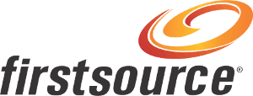  Senior Customer Service Associate  August 2006 to September 2012  • Creates and manages a customer value plan for existing customers highlighting profile, share and value opportunities.  • Identifies advantages and compares organization’s products/services.  • Plans and organizes personal sales strategy by maximizing the Return on Time Investment for the territory/segment.  • Supplies management with oral and written reports on customer needs, problems, interests, competitive activities, and potential for new products and services.  • Keeps abreast of product applications, technical services, market conditions, competitive activities, advertising and promotional trends through the reading of pertinent literature and consulting with marketing and technical service areas.  • Participates in trade shows and conventions.  Promoted as an SME: Being an SME I got an opportunity to train the new batch about the Business process. As a Business trainer I trained 4 batches (New Joiners) about the Process and help to achieve the driven targets assigned by the company. Backed with a team of 10 members (Each batch) my responsibilities to monitor and render feedback to improve the performance as per the assigned target by the company.  PERSONAL DOSSIER:  Date of Birth Marital Status Languages Known Nationality References 04/02/1982 Married English, Hindi, Kannada, Telugu & Tamil Indian Available upon Request  Declaration - I declare that the above-listed information is true to the best of my knowledge. | Contact:  Flat #1508, Tiger Building, L15  Marina Towers  Phone: +971 589734983  Email: hari_nathu@yahoo.co.in  Linkedin: https://www.linkedin.com/in/harish-kumar-261a3b13b  SKILLS:  Leadership  Customer service  Creativity  Organization  Teamwork  Language  Communication & Language:  Excellent presentation and training skills. Business development & escalation.  Communication & Language:  Well versed within the English language.  Exceptional reporting and communication skills between peers, seniors and business colleagues.  Information Technology & Tools: System: Windows, Wintel. ITIL Certified, Active Directory, IAM access.  Packages: Microsoft Office, Wintel  Others: Internet, Computer & Web-based apps  EDUCATION:  B. Com (Computer Science) - SMSG Jain College Bangalore University, India  Pre-University (HEBA) - Kairalee Nikethan College Bangalore University, India  - Skills:  - Strategic Ability to communicate clearly  - Ability to use positive language  - Time management skills  - Goal-oriented focus  - Quality monitoring  - Handling Escalations  - Team Handling skills  - Knowledge of the Healthcare Environment  - Communication and Relation Management  - Business Skills and Knowledge  - Team Management  - Software Skills  - Project Management Skills  - Technical Skills:  Windows and Wintel  ITIL Certified  Active Directory  - Trainings and Certifications:  ITIL Foundation 4 Certificate in IT Service Management, 2018  Certified Personal and Business Banking Specialist with US clients.  Attended and certified training for Voice and Accent Neutralization.  Window Intel certified in Azure Active Directory, 2018.  Completed non call certification & well versed with MS office  Completed basic IT helpdesk Specialist with US clients.

