**NIDA YOUNAS**

Mob: 0506187020

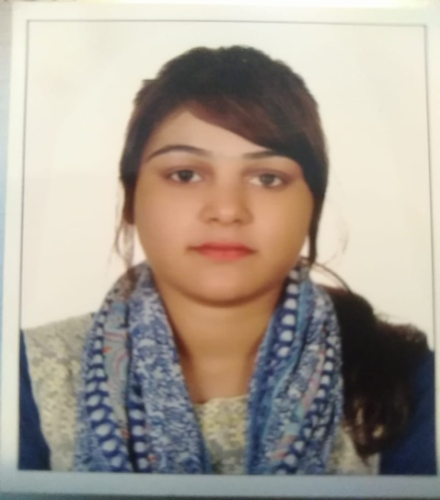

OBJECTIVE & SUMMARY

Dynamic individual with extensive knowledge of doing the best in a given situation, willing to accept a challenging job where I can apply my skills

Highlights

* Effective Team Member
* Ready to learn and growth
* Reliable and trustworthy

Experience & Skills

***Streaks Beauty salon- Dubai U.A.E –*** *Branch Manager* ***(July 2016 to up to date)***

**Duties and responsibilities** *–*

* Staff management, customer care & customer satisfaction
* Hygiene, clean and tidy of the branch,
* Follow up Sales targets and cashiering
* Operating computers with salon ERP soft ware.
* Measuring stock requirements and placing orders to stores.
* Performance evaluation of staff and recommend for incentives
* Organization of quarterly staff get together and other activities

***Sports and activities***

* Participated in annual sports meets and other activities.
* School prefects and proactive member in the class.
* Participated extra activities in the organization

Education and Training

**Board of Education – Lahore , Pakistan -**  Passed 10th standards ( Metric )

**Board of Education – Lahore , Pakistan -**  Passed FA standard

**IT diploma –** Completed 06 month course

**Computer Operating –** Gained standard knowledge

**Other Skills**

* Beauty experts in Facials, wax and all skin work

**Languages**

* English
* Hindi, Urdu and Punjabi

Other Information

**Nationality** : Pakistani

**Date of birth** : 11th June 1997

**Address :** Al Nadha1, Dubai U.A.E

**Religion** : Roman Catholic

**Marital Status :** Single

**Mob No** : 0506187020

**Email Address :** [nehacandy21@gmail.com](mailto:nehacandy21@gmail.com)

**Visa Status:** : Residence visa ending July 2020