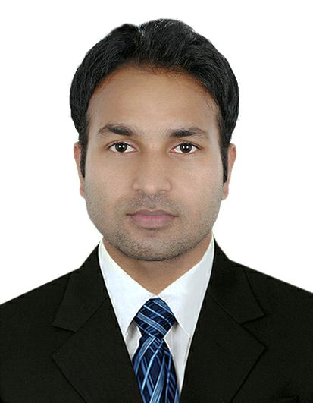
NESSAR AHMED
Al Fahidi , Bur Dubai UAE
CURRENT POSITION- SENIOR SALES ASSISTANT
TOTAL EXPERIENCE- 8 YEARS
Contact No: +971553762872
Email ID: ahmednessar119@gmail.com
SUMMARY: Profoundly talented, knowledgeable and result-oriented with more than 8 years experience in leading a team that serves, welcomes, and advises customers; including providing sales leadership, driving revenue growth, profit growth.
ACHEIVEMENT:
- I got sales associate of the Month and also a year.
- I received appreciation from the operation head, regarding my sales achievement
- I got appreciation from the manager when i arranged backstore genderwise,categorie wise and brand wise.
- I earned appreciation from the customer personally and also in front of my store manager.
- Usually out of 18 staff I achieved 100% of my target.
KEY SKILL:Cummunication and customer service skill,cashering,adaptable,work under pressure,relationship building,dealing with difficult people,respect for leaders and co workers,visual merchandising,ms office.

Professional career profile:


SENIOR SALES ASSISTANT 18th APRIL 2013 TILL DATE SUN AND SAND SPORTS
Major Tasks and Responsibilities

- Promote and support the high quality sun and sand sports company image through professional selling.
- Reporting to Store Incharge.
- Explain product features and benefits, as well as technical specifications, to customers.
- Reinforce the importance of comfort and service by professionally fitting every customer with the proper footwear.
- Ensure that every customer receives the highest level of customer service.
- Maintain and promote merchandising standards in the store.
- Drive business at the store level coaching merchandising and selling skills.
- Study and know the strengths and weaknesses of competitors' products.
- Recommend, select, and help to locate or obtain merchandise based on customer needs and desires.
- Maintain and arrange the stock room on daily basis.
- Maintain and arrange the floor by model wise and category wise.
- execute the cash accurately and fast.

Professional Qualification:

- Six Month Diploma in computer application.
- Ms. Office ,Ms. Outlook, Internet.
- One year diploma in apparel design course.

Academic Qualification:

Year of Passing | Examination | Board
2010 | Graduation (B.A.) | North Bengal university
2006 | 12th Standard | West Bengal board
2002 | 10th Standard | West Bengal board
Personal Details:

Marital Status : married
Birth Place : Darjeeling
Nationality : Indian
Religion : Islam
Language Known : English, Hindi, Nepali, Urdu & Arabic (Read)
Passport Details:

Passport Number : M7147681
Place of issue : Dubai
Visa status : employment transferable

