**CONTACT**

+971 508868728

Sardarumair928@gmail.com

[linkedin.com/in/umair-sardar-b9b03b165](https://www.linkedin.com/in/umair-sardar-b9b03b165)

Dubai UAE

**SOFTWARE**

REVIT (BIM)

AUTO CAD

SKETCHUP

MS OFFICE

PHOTOSHOP

**SKILLS**

COMMUNICATION

CREATIVITY

TEAMWORK

ORGANIZATION

LEADERSHIP

TEAMPLAYER

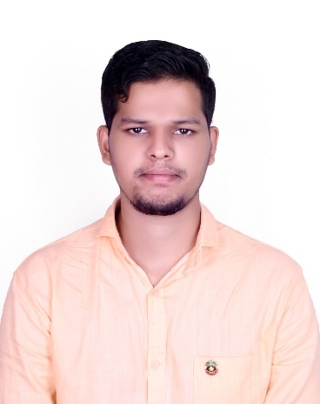

MOHAMMED UMAIR

BIM MODELER (Architectural & Structural)

**OBJECTIVE**

To seek a challenging & innovative carrier in the field of Architectural Designer/ Draftsman / Structural Detailer and HVAC designer in any substantial Organization this promotes to establish myself as renowned professional and towards the growth of Organization.

**Work Description**

. Provide CAD drafting/BIM modeling and design support.

. Coordinate and manage Revit models.

. Prepared Shop Drawings All Type Of Civil & HVAC Systems

. Prepared Shop Drawings Interior Fit Out And Joinery Details.

. Create Revit families and CAD blocks.

. Obtain work assignments of either specific design elements or CAD drafting from project managers.

. Produce architectural / Structural drawings using AutoCAD.

. Able to learn and retain new skills quickly from a variety of sources and show potential to work with limited supervision And Design conceptualization as per client requirements.

**PERSONAL**

Birthday : 01st October 1995

Relationship : Single

Nationality : Indian

Languages : Hindi, English, Urdu

Visa Status : Employment Visa

**Experience**

**Civil Draughtsman** Sep 2015- Oct 2016

Nirman Infrastructure Pvt. Ltd Ratnagiri

**Architectural Draughtsman** Nov 2016- Feb 2018

CAD Access Ratnagiri

**HVAC Designer** Mar 2018- Apr 2019

Mercury air conditioning Pvt. Ltd. Lalbhag Mumbai

**BIM Modeler & Civil Draughtsman** May 2019- Till date

General Construction Company LLC. Dubai UAE.

**Education**

**INTERIOR DESIGN AND DECORATION**

Government Industrial Training Institute Ratnagiri 2012 – 2013

**DIPLOMA (CIVIL ENGINEERING)**

Indian Institute of Engineers Maharashtra India 2015 - 2017

**DRAUGHTSMAN CIVIL**

Government Industrial Training Institute Ratnagiri 2013 – 2015

**B-Tech (CIVIL ENGINEERING)**

Indian Institute of Engineers Maharashtra India 2017 - 2020

**STRENGTHS**

. Good oral, written & presentation skills.

. A high tolerance of stress and enjoys responsibilities.

. Quick learner with good grasping ability.

. Action-oriented and result-focused.

. Lead & work as a team in an organized way.

🌍

🖂



