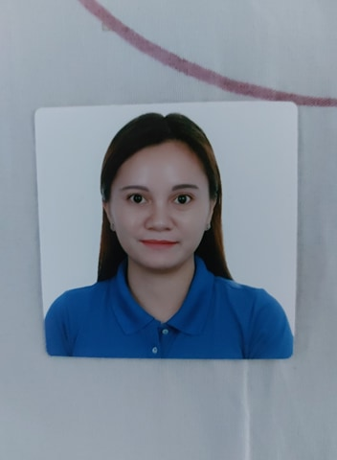**CURRICULUM VITAE**

**May Alfanta Dela Cruz**

**#303 San Isidro, Cabanatuan City  
Contact No. +63975 041 4422**

**Email:** [**ivymaykaren03@gmail.com**](mailto:ivymaykaren03@gmail.com)

**Post Applied for: Cashier**

**Objective**

A suitable position with an organization where I can utilize the best of my skills and abilities that fit my education, skills and experience a place where encourage and permitted to be an active participant as well vital contribute on the development of the company.

**Educational Qualification**

* Elementary
* High School
* Tesda Massage Therapist

**Personal Strengths**

* Ability to work independently or in team
* Excellent communication or in good team worker
* Fast learner, hard worker and result oriented

**Work Experience**

* Sales intern
* Sm department store 2015-2017
* Training at Aida Roque Academy Hair and Beauty Care

**Personal Details**

Date of Birth : May 3, 1989

Nationality : Filipino

Gender : Female

Marital Status : Single

Language : English, Filipino

Religion : Catholic

Passport : P0976410B

I hereby declare that the above information is true and correct to that best of my knowledge and belief.

**Declaration**