BIPIN JOSE  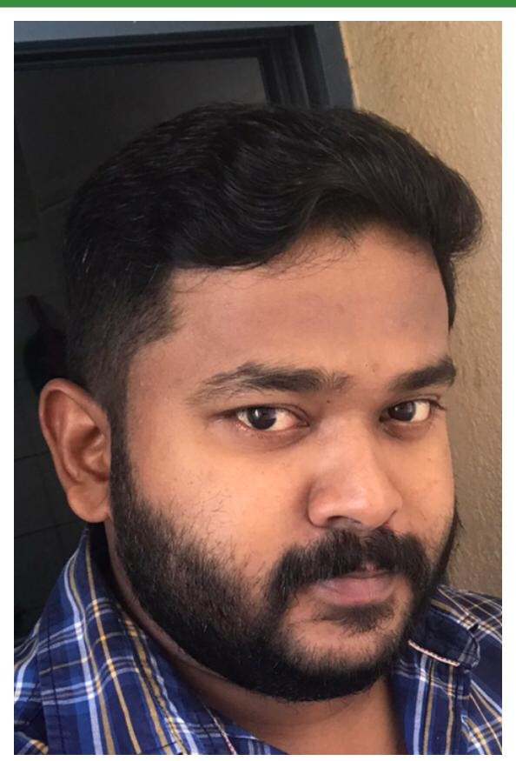  CONTACT  Present Location: Dubai  Phone: +971 558014774  Email:  bipinjosenewfield@gmail.com  PERSONAL DETAILS  DOB: 07/07/1989  Nationality: Indian  Marital Status: Married  Permanent Address: Puthiyapambil House,  Parathanam (P.O),  Kottayam,  Kerala - 686514  SKILLS  - MS OFFICE  - TALLY  LANGUAGES KNOWN  - MALAYALAM  - ENGLISH  - HINDI  - TAMIL  PASSPORT DETAILS AND VISA STATUS:  Passport No: K0080845  Date of Expiry: 08/04/2022  Place of issue: Cochin  Visa status: Residence Visa  Valid from: 05/01/2019  Valid until: 04/01/2021 |  | CAREER OBJECTIVE  To be a part of an organization where I can get a chance to learn new things, which helps to increase my growth and which leads to the organizational growth.  WORK EXPERIENCE  ODESSA HIERARCH MANAGEMENT CONSULTANCY L.L.C, DUBAI  ACCOUNTS MANGER  From May 2018 to Till date  MALABAR GOLD AND DIAMONDS, CHENNAI,INDIA  SALES AND ACCOUNTS COORDINATOR  From February 2015 to March 2018  POTTAMKULAM FARM HOUSE ,CUMBUM, INDIA  ASSISTANT MANAGER  From April 2011 to December 2014  RELIANCE SUPERMARKET, KERALA , INDIA  BILLING CLERK  6 Months  HIGHLIGHTS  Basic Computer Knowledge  Aware the computer related tasks  Ability to work effectively in a team environment  ACADEMIC CREDENTIALS  - B. Com  (MG UNIVERSITY) -2007-2010  - HIGHER SECONDARY EDUCATION (KERALA STATE BOARD) -2005-2007  - SSLC – March -2005  QUALITIES  - TIME MANAGEMENT  - QUICK LEARNER  - GOOD COMMUNICATOR  - ADAPTIVE  - RESPONSIBLE  - FLEXIBLE  - PROBLEM SOLVING  DECLARATION  I hereby declare that the details furnished above are true and correct to the best of my knowledge and belief.  Place: Dubai  Date:  BIPIN JOSE

