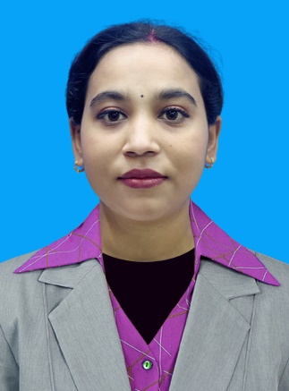
CURRICULUM VITAE

KHUSI BISHWAKARMA
Reggae, Blk-2, St.-21 Bld.9, Kuwait
What’s App Number-00965-51632258 /51161329
Email-khushi75891@gmail.com

________________________________________________________

OBJECTIVE:
Seeking a challenging position that utilizes my strong experience and extensive background while offering room for advancement in exchange for consistent productivity, unparalleled dedication and unbroken integrity either working individually or collectively to contribute of the objectives of the organization.

PERSONAL INFORMATION :
Name : Khusi Bishwakarma
Marital status : Married
Nationality : Nepali
Date of Birth : 23-09-1993
Place of Birth : Prashpur,Sunsari Nepal
Passport Number : 10347111
Date of Expires : 15-04-2027
Height : 4’5
Weight : 46
Language : English, Basic Arabic, Nepali, Hindi

EXPERIENCE:
- October 16-10-2017 to Nov 18-11-2019 Sales Girl & Makeup & Hair Ardists In Marval Saloon in Kuwait

- March-10-2013 to June-28-2015- Cashier and server at Hotel Nirvan Jhapa, Nepal

- Dec 13-12-2019 to Oct 25 -10-2022 cashier and Team member at Pizza Hut ( Kout Food Group Kuwait )

EDUCATION:
- 10 class passed Himalayan English school
- +2 passed Himalayan multiple university collage, Dhulabari Jhapa, Nepal

SUMMARY OF SKILLS :
- Team work, independent, motivated. Ability to learn quickly
- Fast reliable and precise
- Respect and appreciate teamwork Able to work well under pressure Excellent communication skills

ACHIEVEMENT:
- As a good relationship with the customer mania marvel Saloon & SPA at training course.
- Customer service
- Sales motivated with the customer
- Recognized by management team for hard working and teamwork

KEY STRENGTHS AND SKILLS:

- Ability to work in Shifts and in situation calling for total dedication, creative good in implementation of ideas and decision making
- Good communication and interpersonal skill

HOBBIES AND INTERESTS:

- Travelling, hiking, cooking, playing games, listening to music and playing guitar
- Excellent references on requested.

_______________________________________________________________

Dear Sir/Madam,

I have heard from reliable source that you have vacancy for some time in your establishment. Please consider me as an applicant.

I am Khusi Bishwakarma hard working, responsible, dedicated to work and fast learner person. My previous job experience taught to how to work as team or individual and deal with people as well as do the all the work related paperwork’s. I am confident enough that I can be useful in said position.

I am very much willing to attend the interview at your most convenient if I am given this opportunity. I thank you in Advance.

Sincerely,

KHUSI BISHWAKARMA
What’s App number-00965-51632258/51161329
Email : khushi75891@gmail.com

