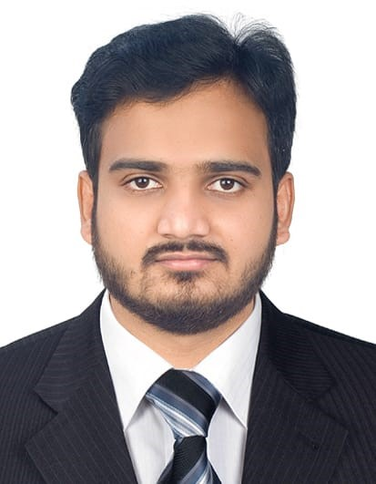 CURRICULUM VITAE

**MOHAMMAD ZAKIR HASSAN**

**Business Development Executive**

Cell no: +971-582125627

Email: [mohammedgnt92@gmail.com](mailto:mohammedgnt92@gmail.com)

**Professional Summary**

Expert business strategist with a sound understanding of organizational development and sales. Skilled communicator with over 6 years of experience providing companies with successful solutions to building organizational success. Persuasive negotiator who uses integrity and professionalism in presenting joint ventures, assessing acquisition opportunities, and identifying new markets. Innovative thinker who detects more efficient ways of growing company assets by recommending new products, revolutionizing current product offerings, and testing new market approaches.

**Skills**

• Expert strategist who uses research of competitors, market conditions, customer needs, and organizational core competencies to claim company success.

• Skilled communicator and negotiator who understands persuasive delivery and can confidently present sales pitches to potential partners and reports to board members.

• Confident salesman who combines enthusiasm, product knowledge, and customer assessment to pitch products in a way that increases brand awareness and encourages product loyalty.

• Accomplished understanding of financing activities, including budgeting, investing, and cost-cutting through careful analysis.

• Strong organization and time management skills and careful attention to detail to guarantee that business ventures are successful and development is absolute.

resource planning, in-process inspection, team building and co-ordination with parallel working departments.

**Core Competencies**

**Square Yard Real Estate**, Dubai

**Real Estate Sales Agent**

1. Present purchase offers to sellers for consideration.
2. Interview clients to determine what kinds of properties they are seeking.
3. Communicate with escrow companies, lenders, home inspectors, and pest control operators to ensure that terms and conditions of purchase agreements are met before closing dates.
4. Promote sales of properties through advertisements, open houses, and participation in multiple listing services.

**Emirates Steel Industries** 2017-2021

Business Development Executive

ABU DHABI, UAE

**Roles & Responsibilities:**

. • Strategize ways to build market share, increase revenue, and acquire success through innovative developments in organizational structure.

• Facilitate sales presentations and communications for upcoming joint venture opportunities and collaborative business efforts.

• Identify ways to build brand awareness through engaging campaigns that establish the company reputation, incite curiosity, and inform potential customers.

• Establish product loyalty through continual efforts to build, re-brand, modify, and increase product offerings in a way that is honest, competitive, and true to the company missions

**Dubai Garden Centre** 2016-2017

Sales Development Executive

Dubai, UAE

• Managed four area market managers in their respective jurisdictions to verify market growth, accessibility, and areas of improvement.

• Evaluated competitors in terms of market share, product offering, recognizable strategies, and advertising efforts to determine strategies that would strengthen our company’s presence in those areas.

• Researched market conditions, including customer interest and availability, product need, economy volatility, access to resources, and shipping requirements, to make confident decisions in pursuing, maintaining, and strengthening market opportunities.

**BMW Motors** 2015-2016

Sales Development Executive

Dubai, UAE

• Oversaw a group of five area sales managers and collaborated with each to identify the progress, opportunity, and condition of each jurisdiction.

• Lead monthly trainings for executive management to provide them with recent research on best practices, sales strategies, and competition movement.

• Contributed to the company recognizing a nearly 20 percent increase in yearly revenue through a recommended sales training to teach sales professionals about proper negotiation and closing tactics.

**Academic**

## **Education**

## 2014: Bachelor of Engineering in Electrical and Electronic from Jawaharlal Nehru Technological University

## **Personal Details**

## 

**Date of Birth:** 6th February 1992

**Languages Known:** English, Hindi, and Urdu& Arabic

**Address:** Al Neisseria Dubai, UAE

**Visa Status**: Visit Visa

**Driving Licences**: UAE driving Licences