CURRICULAM VITAE

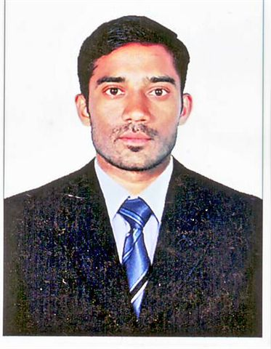 RAMESH LINGALA
UNITED ARAB EMIRATES
E-mail:ramesh.lingala@hotmail.com
Mobile: +97155-9094 572

CAREER OBJECTIVE:
To establish my self as a successful professional and to work in a competitive atmosphere this provides a platform to constantly upgrade my knowledge and skills and to grow along with the organization.

EDUCATION QUALIFICATION:
s.s.c: Secondary School Certificate Passed in The Year of 2001-2002 At Bheemaram
S.H.S.C:Secondary High School Certificate Passed in The Year of 2002-2004 At SKNR junior College Jagtial.JAGTIAL (Dist)
BSc(bzc): Bachelor In Science In The Year of 2004-2007(But One subject Appear) At SKNR Degree college Jagtial,JAGTIAL(Dist)

WORK EXPERIENCE:
- I Have been working in Pioneer Insurance Brokers As Office and Administration Assistant.
- I Have started working in this company on 2009 march17th ,I Have atleast 6 and Half years of experience in administration(HR). I was working multi tasking roll on work pressure.

TECHNICAL SKILLS:
- Software : MS Word, MS Power point, MS Excel,ITknowledge,Web Browsing
- Accounting Software: Tally 9.0

KEY RESPONSIBILITIES:
- Updating various Excel spreadsheets for employee benefits and various company related spreadsheets
- Process new employees through the company orientation program which includes company rules, regulation, culture, etc
- Helping employees with insurance claims
- Handling leave records and attendance system with the HR manager
- Assisting safety manager in the wellness program, safety incentive program and workers compensation claims.
- Maintaining personal files of employes and documentation.
- Explaining the policies, procedures, benefits, and what will be expected from them as new emloyees
- Making sure that every employee is aware of safety procedures before they start work at the facility.
- Working with the Corporate HR director, carrying out disciplinary actions with an employee
- Processed the weekly garnishments and payroll deductions.

PERSONAL DETAILS:
NAME : RAMESH LINGALA
DATE OF BIRTH : 20/SEP/1985
LANGUAGES KNOWN : ENGLISH, HINDI, AND TELUGU
SEX : MALE
MARITAL STATUS : MARRIED
DRIVING LICENSE : VALID DRIVING LICENSE (Automatic)
PASSPORT&VISA DETAILS:
PASSPORT NO : N8548395
PASSPORT ISSUE : 10/03/2016
PASSPORT EXPIRY : 09/03/2026
VISA STATUS : RESIDENCE VISA

DECLERATION:

I do here by declare that the information given above is true to the best of my knowledge.

RAMESH LINGALA

