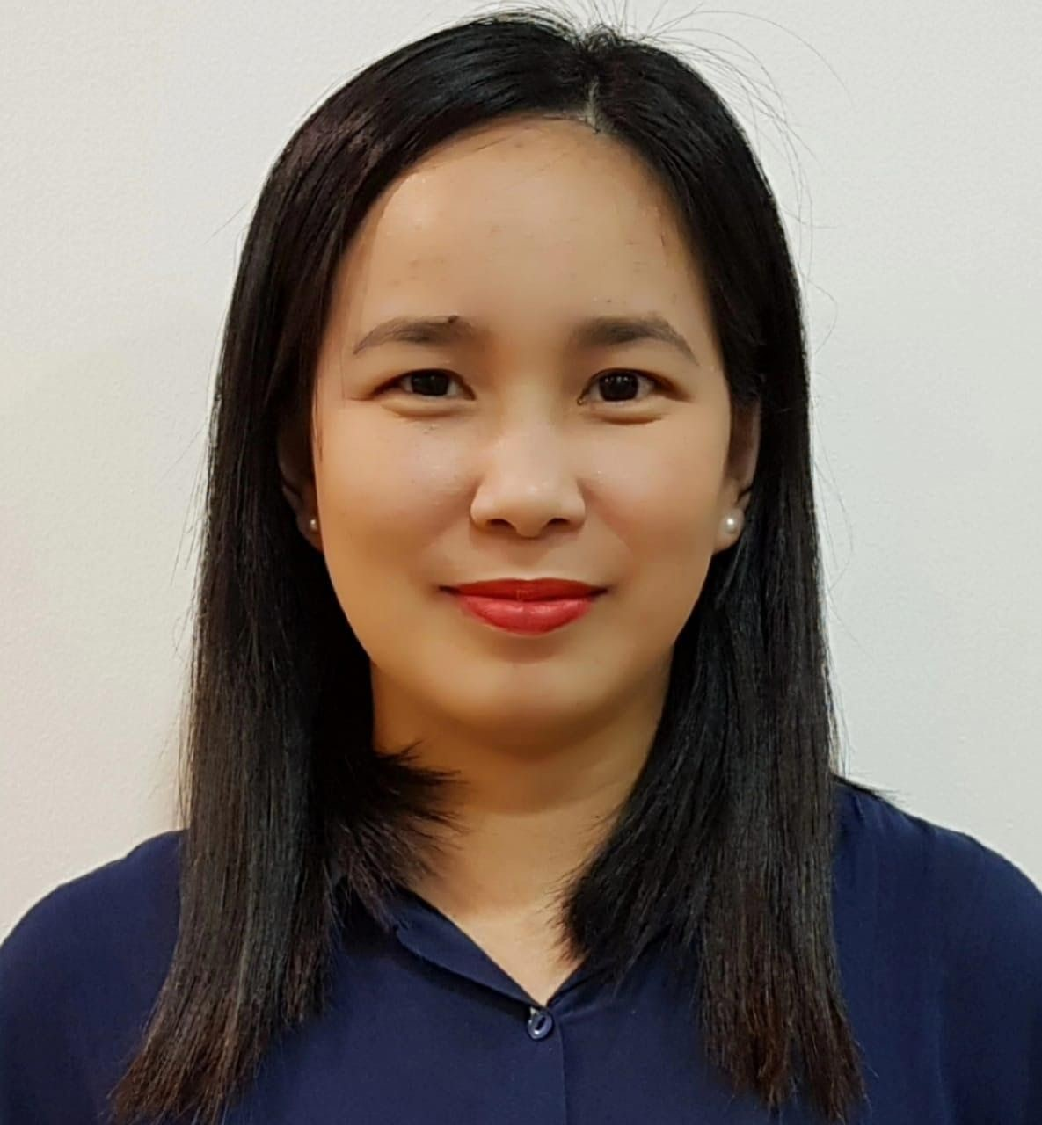

***JOSTLE OPILAS DONDOY***

Al Falah St. Abu Dhabi, UAE

Mobile Number: **0551153913**​

Email Add: **jostle.opilas@gmail.com**​

**Customer service oriented, self motivated and caring Receptionist with extensive experience in resolving conflicts with customers. Thorough and attentive to detail in all professional matters.**

# SKILLS

***Office Skills:*** ​*Front Desk Reception – Database and Records – Management – Reports and*

*Spreadsheet – Complaint handling – Data Entry (60wpm) – Multi tasking and prioritization*

***Computer Skills:*** ​*Microsoft*​​*Office Proficiency (Word/Excel/PowerPoint).*

# PROFESSIONAL EXPERIENCES

**RECEPTIONIST/ FOLLOW UP CLERK**

**March 08, 2016 – September 17, 2020**

**ORIENTAL BEAUTY SPA AND FITNESS**

**ABU DHABI, UAE**

***Job Description:***

1. Make client bookings/ reservations
2. Upselling of products and services
3. Welcomes visitors by greeting them, in person or on telephone; answering or referring inquiries.
4. Collects and processes payments using Cash and Visa/ MasterCard.
5. Prepares financial daily reports of sales at the end of the day.
6. Maintain and update office files, inventory and database systems.
7. Compiled and submitted reports to the Supervisor regarding accomplishments and updates. 8. Operate office equipment like personal computers, photocopier, scanner and facsimile machine.

## 9. GYM RECEPTIONIST (FITNESS DEPARTMENT IN CHARGE)

* Monitor clients Membership for Gym and Pool, keeping and properly updating their monthly body assessment with BMI records
* Arrange booking for Personal Training and Swimming Classes
* In charge in preparation of Monthly Fitness Classes coordinating with Freelancers
* Knowledge on the operation and maintenance of Gym and Pool equipment and facilities.
* Maintained a record of all guests and members coming to the gym and attending fitness classes.
* Resolved all customer complaints making sure the customers were satisfied with the service they were receiving at all times.

**ADMIN ASSISTANT**

**November 04, 2002 – February 15, 2016**

**FUJITSU TEN EMPLOYEES MULTI -PURPOSE COOPERATIVE**

**LAGUNA, PHILIPPINES**

***Job Description:***

1. Produce and distribute minutes of meeting, correspondence, memos, letter, faxes and forms
2. In charge of Bank Transactions, Cash Receipts, Disbursements, Petty Cash and

Liquidations.

1. Prepares purchase orders for goods, supplies and basic commodities from various suppliers.
2. Act as Bookkeeper/ Cashier and Loan Officer.
3. Provide and submit monthly reports on the status of the Company’s operation, its targets and recommend appropriate policy or operational changes, if necessary;
4. In charge of Payroll and other government related documents
5. Conducts and prepares month-end schedule of Accounts, list of physical inventory of all goods/supplies/basic commodities with the assistance of the Committee on Audit, staff & B.O.D oversight.
6. Carry out administrative duties such as filing, typing, copying, scanning etc.
7. Handle sensitive information in a confidential manner.

**May 15, 2002 – October 30, 2002:**

## OFFICE ASSISTANT 1 (​ GENERAL AFFAIRS SECTION)

**FUJITSU TEN CORPORATION OF THE PHILIPPINES**

**November 2001 – May 2002:**

**OFFICE STAFF**

**MESA MANPOWER CORPORATION**

**May 21, 2001 – October 31, 2001:**

**PURCHASING STAFF (OJT)**

**F TECH PHILIPPINES MANUFACTURING INC.**

**May 03, 1997 – November 03, 1997**

**CASHIER/ SERVICE CREW**

**JOLLIBEE FOODS CORPORATION**

1. Take orders from customers and present them as requested
2. Process bills for the customer and issue receipts
3. Help with outdoor delivery or with food preparation at the kitchen depending on what is required at any particular time
4. Pack foods ordered by customers and serve them in the most efficient manner.
5. Set the table in an orderly manner before customers show up 6. Get tables cleaned once customers are through with their dining.

# EDUCATIONAL BACKGROUND

**Tertiary Level**

**BACHELOR OF SCIENCE IN COMPUTER SCIENCE**

Laguna College of Business and Arts

Calamba City, Laguna

1997 -2001